Tonbridge Grammar School PTA
Deakin Leas, Tonbridge, Kent TN9 2JR
Tel: 01732 365125
Website: www.pta-events.co.uk/tgs
PTA Email: pta@tgs.kent.sch.uk

TGS Family Fun Quiz
Friday 7th October 2016
Tickets £12 adults/£10 under 18s

Welcome from 7:30pm - first question at 7:45pm, aim to end by 10:30pm.
Teams of eight/nine people - secondary school children welcome to “support” parents in teen rounds..!
You can arrange your own team OR just book for yourself and we will make sure you are not alone! A great way to meet other parents.
Ploughman’s Supper served at 8:30pm followed by a

PUDDING AUCTION

Delicious Homemade Puddings will be auctioned off to the highest bidder.

Licensed Bar and soft drinks will be on sale throughout the evening.

There will be plenty of fun and plenty of prizes including bottles of Bubbly – and not just for the winners. Ticket applications are processed ‘first come, first served’ so book quickly!
Tickets are available now through our website at www.pta-events.co.uk/tgs
If you are able to offer a pudding for the auction, you will be able to do so under the “Can you help” section.
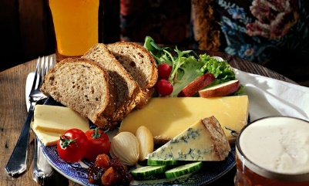
It will be a family fun night we look forward to seeing as many of you there.
All money raised will go to the PTA.
Thank you!

