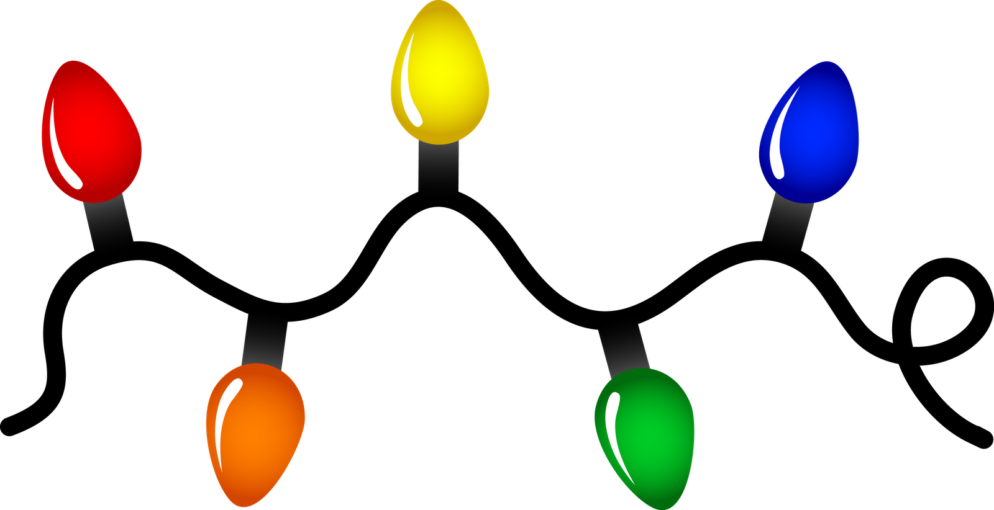

**SS Peter & Paul**

**CHRISTMAS FAYRE**

**Saturday 1st December 2018**

**11am – 2pm**



**Raffle**

**Games**

**Tombolas**

**Arts & Crafts**

**Refreshments**

**Santa’s Grotto**

**Christmas Bake Off**

**Christmas Gift Stalls**

**And much more…………..**



**SS Peter & Paul**

**CHRISTMAS FAYRE**

**Saturday 1st December 2018**

**11am – 2pm**

**Raffle**

**Games**

**Tombolas**

**Arts & Crafts**

**Refreshments**

**Santa’s Grotto**

**Christmas Bake Off**

**Christmas Gift Stalls**

**And much more ………….**





   