Ringwood Junior School waves: 2.6K = Wave 17 & One Mile = Wave 21

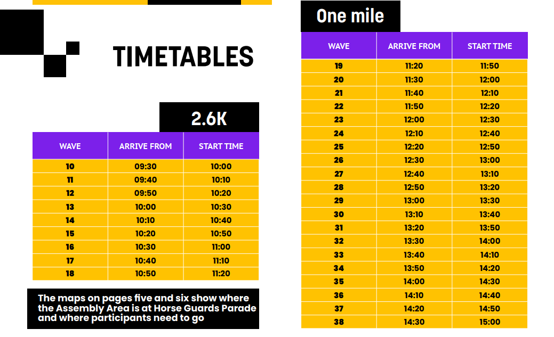

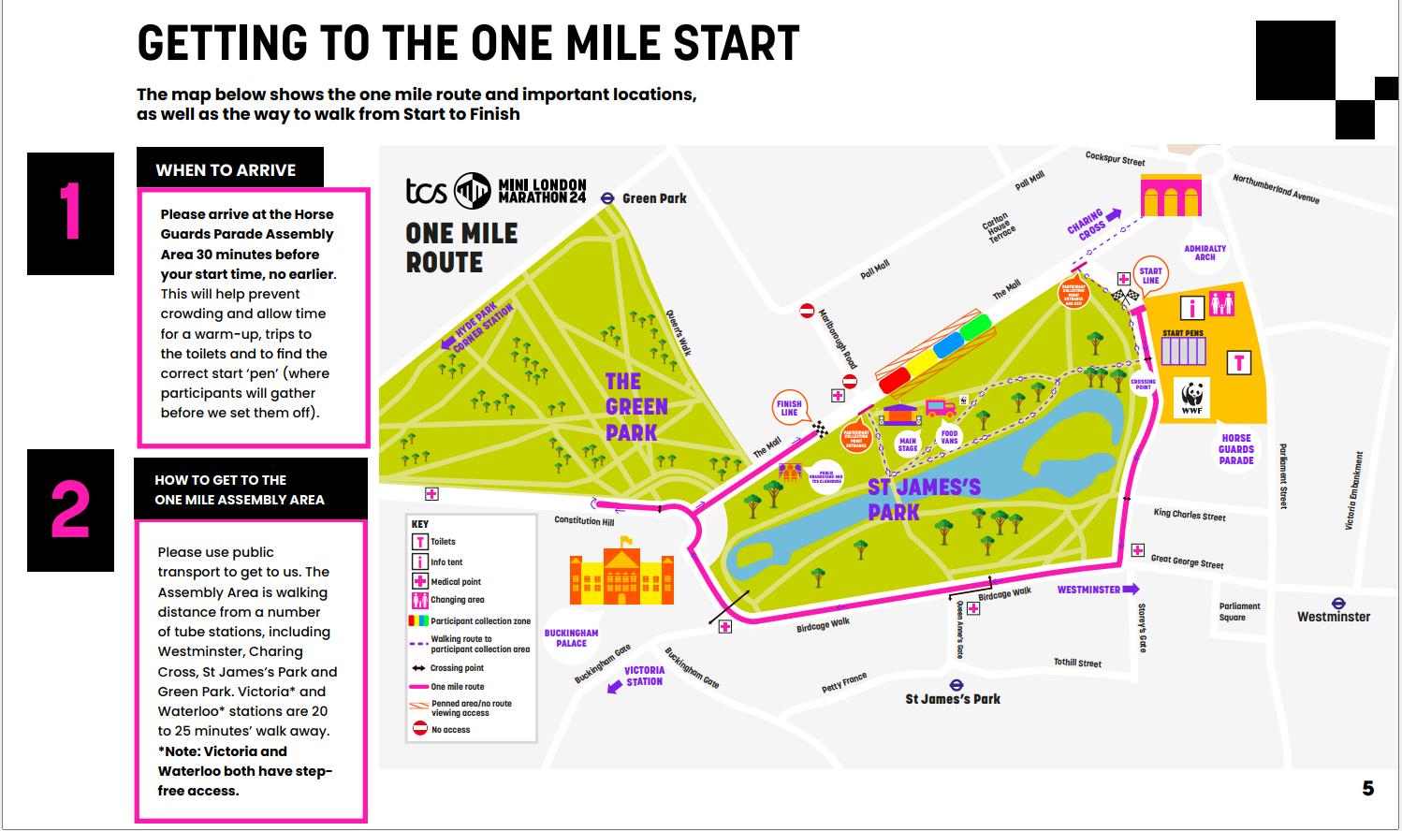
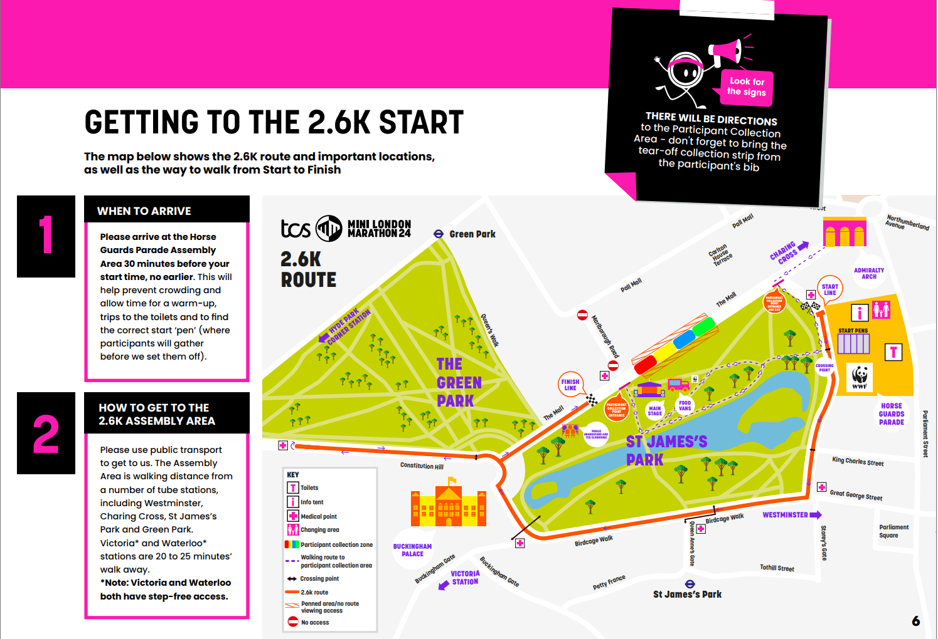
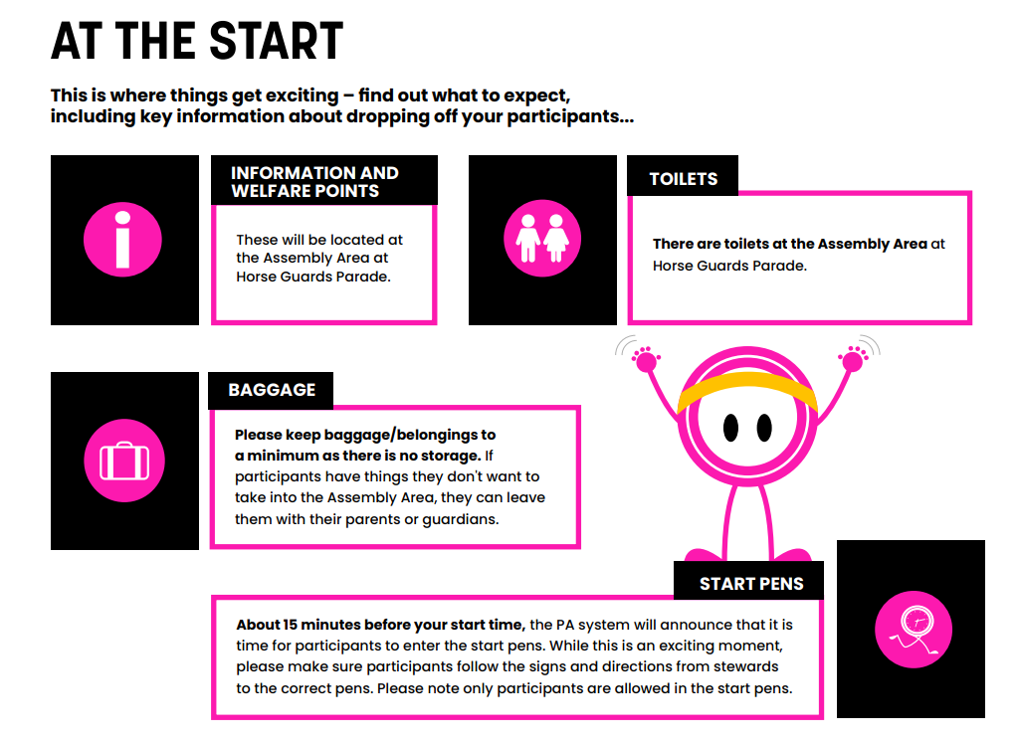
Important: Drop off
If the participant is running on their own (only if they are in Year 3 or above) they will need to be accompanied until they are safely in the start pens.
Larger groups should have sufficient number of adults to supervise everyone. The start pens are a secure space where the participants can wait until the allocated start time.
Remember to make sure all allocation strips have been torn from the bib numbers and are kept safe by the adult who ia collecting the participant/s.
Once participants have been dropped off at the start pens, head off to watch them on the route, or from the Public Grandstand on The Mall. It’s then just a short walk to the Participant Collection Are.

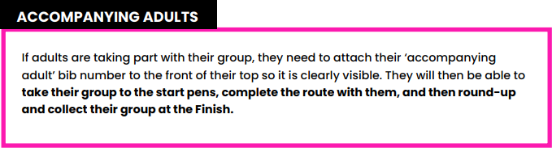

Tell your children
IMPORTANT: staying safe on the route
If you have participants taking part on their own, please make it clear that they should follow the route to the finish. They don’t have to run the whole way, so if they need to stop and walk to get their breath back, that’s fine. They should only drop out for medical reasons and must not leave the route at any point along the way.

