12th JULY 2018 CIRCUS ARTIST PROFILES
Mr Happy
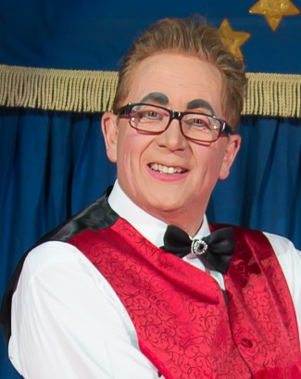
Russ has followed in the footsteps of his father who performed as Clown Ki-Ko with Walker the Dog appearing on Billy Smart’s Circus in the 1950’s. Russ, a former Royal Marine has been an entertainer virtually all of his life. He started work in Children’s theatre, then worked in shopping centres, at children’s parties & performing street theatre. He has also worked in comedy bands, dance troupes, at Butlins & Warner Haven Holiday Camps and for Santus & Zippos Circuses.

Happy’s Circus was created when Russ was approached by his children’s school PTA who were looking for a different way to raise funds for the school. Russ is the recipient of two prestigious International Clown Awards, Happy was chosen to be one of the clowns in the Johnny Vaughan Show: ‘Clowns Across the Pennines’ which launched BBC3 in 2003. He has also appeared with Ainsley Harriott on ‘Celebrity Ready Steady Cook’ and innumerable roles in theatre and TV.

He has been cast as Dame in several pantomimes across the UK. But nothing has surpassed Russ’s proudest memory when he was invited to attend the Queen’s Garden Party in 2012 at Buckingham Palace. Russ is a member of Equity, The Association of Independent Showmen & The European Circus Association. He is honoured to be treasurer of the Association of Circus Proprietors of Great Britain, a role which keeps him very busy.
Russ is Managing Director and founder of Happy’s Circus. He is Director of the Blue Unit, he manages the Blue Unit circus, assisted by his fiancée Pat Holmes, Front of House Manager. Mr Happy has his hands full looking after Serhiy the clown, watch out for loads of fun.

Serhiy the Clown
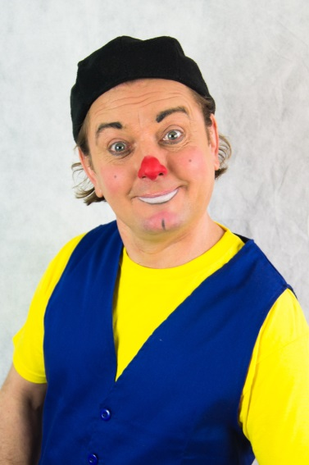

Serhiy Valkiv began his circus career as a young boy in the Ukraine. He did not come from a traditional circus family but he had a good gymnastic strong body and he wanted to challenge himself and travel the world. His parents managed to get him to the Karandash, the world-renowned Moscow circus school, where at the age of fourteen he won a place to study. He trained in all aspects of circus and excelled as an acrobat. He trained in Russian bar and Russian swing. He was always the smallest so he became the flyer, being tossed into the air time & time again. He was also a funny little man & comedy oozed from him at every opportunity, never needing language to communicate his physical comedy. He won a gold medal in 1990 @ the International Circus Festival of Belgium whilst still a student.

He progressed to flying trapeze & straps working as the flying acrobat in many circuses across Europe including the Budapest State Circus in Hungary, Cirque Medrano in France, the Florilegio Circo Togni and Circo Weber in Italy. He also worked at x in the then Czech Republic, and the Arnardo Circus in Norway.
It was at the Cardenal Circus in the Canary Islands in 2002 that Serhiy first appeared as Clown developing his very individual rapport with the audience.

In 2012, Serhiy crossed the English Channel to work on the Booby Roberts Circus, the Iconic Circus of Horrors & Happy’s Circus. The Blue Unit is named after Serhiy who wears a blue cap. We look forward to seeing the unique comedy of Serhiy & Mr Happy in 2018.

Micaela Cardona – High Bicycle
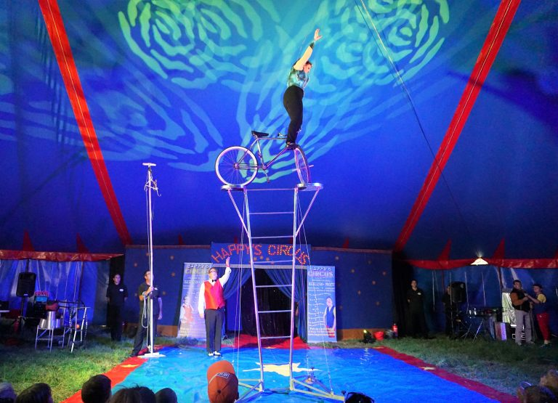
Micaela Cardona hails from a family steeped in the legend of Circus. She is 5th generation circus which means that her family, the Cardona Family were circus performers (on the sides of both of her parents) for four generations before her birth. She was raised on tour, travelling around the world with her parents, learning long distance and performing in the ring from the age of four. Micaela speaks her native Italian, French, Spanish, Russian and English.
Micaela started her full-time career in circus at the age of fourteen at the Errani Circus in Italy. She worked with her family in Flying trapeze performing at Cirque d’Hiver in Paris, Circo de Angel Cristo in Spain, Circo Chen in Portugal, Circo Bizzarro in Italy, Circo Raluy in Spain and Circo Benito Larible in Italy & Spain.

At the age of twenty-one Micaela’s mother trained and passed onto her daughter the spectacular High-Bicycle Act which had been passed from one generation to the next of her family, when suitable talent appeared. It took many years for Micaela to perfect this incredible balancing act. Micaela moved to Paris in 1994, where she trained in a new act balancing swords & daggars at the Ann Fratellini Circus School. Micaela was invited to train the students in circus arts and fixed trapeze where she taught for a couple of years.

Micaela then travelled the world, performing her amazing Sword & Daggar act. With Circo Florilegio, she performed in the Netherlands, Luxembourg, Belgium, France, Italy, Ireland and the UK. More recently she has appeared in the UK with the Bobby Roberts Circus, the Iconic Circus of Horrors & Happy’s Circus.

We are proud to have Micaela working on the show, she is a font of great knowledge, a real team player, excellent Linguist and always ready to share her experience with the next generation.

Shaun & Pippa
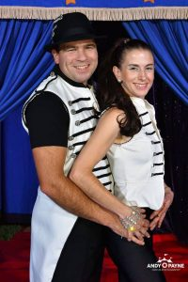
Shaun & Pippa have worked together in Circus for over ten years. They were both besotted with Circus from a very young age. Both have interesting varied backgrounds and come to Happy’s Circus with a variety of skills. Shaun first performed at the age of four when he found himself in the ring of the visiting circus displaying an amazing young aptitude for diablo. His mum loved circus and they attended every circus they could. Each summer, Circus Toppers would visit their village and each year Shaun would perform in the ring, this then developed into a summer job. Shaun learnt as many basic circus skills as he could and adapted well to the Circus life.

He left to join Happy’s Circus where he met his wife to be Pippa. Pippa was a drama teacher who yearned for a life in circus and she was accepted to train at the Aircraft Circus Training School where she learnt trapeze and did indeed leave her teaching job and ran away to join the circus.

Together they are a formidable couple having accumulated a wealth of experience from working in many circuses throughout the UK and France including Mr Fips Wonder Circus and Circus Starr. They excel in a whole range of circus skills including duo diablo, plate spinning and many magic illusions. Shaun and Pippa are also regularly in demand in the world of Corporate Entertainment & galas. In 2011 they featured in the Dionne Bromfield “Yeah Right “video where they had great fun displaying their plate spinning and juggling skills.

New for 2018 Shaun will be emulating the escapologist Houdini in performing “The Great Fire Escape.” Pippa will be performing her original bubble wire act which is her own conception, so if you see it anywhere else, they will have copied Pippa!

Sergey and Svetlana
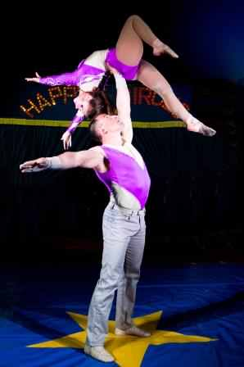

Sergey was born in the Ukraine. He comes from a traditional Circus family His mother also ran a Circus school where he learnt the basic skills of acrobatics, aerial gymnastics and juggling on which his Circus career has been built. He toured the world with his family learning all aspects of circus. Svetlana attended the school from the age of sixteen. They were paired as an acrobatic duo and shared a great passion for their craft. They were always rehearsing new routines, enjoying great popularity with audiences, competing in many competitions and festivals.

Of course, they fell in love and were married. They have travelled the world, working together in the circuses of Ukraine, Russia, Belarus, Kuwait, Egypt, Iran, Montenegro, Bulgaria and Turkey. They are always looking to develop their acts. For 2018 we will enjoy, solo aerial straps, aerial silks and their enchanting adagio.

On the personal side they have a young son, little Ilya who at less than two years old, his parents say is already being prepared for a life in Circus. As is traditional in the Ukraine, he remains at home with the extended family of Serhii’s parents whilst Serhii and Svetlana travel the world. The Molchanovs are always challenging themselves to create new routines; they say they don’t know how to stop moving forwards. Watch this space.

