PTA Early Years Tea Towel Fundraiser

Stuck to what to get all the relatives for presents?
Want a lasting memory of your child’s first years at school?
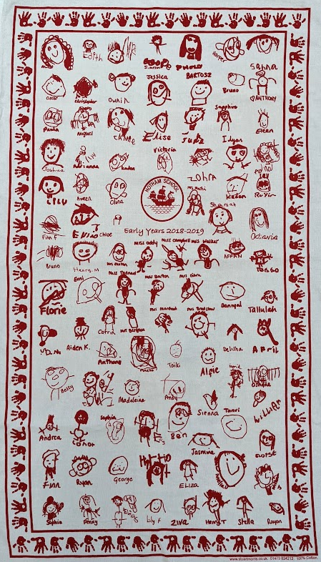
Look no further!

Pre-orders only- £4 per tea towel.
You can order as many as you would like – the more we order the more we raise for the children. The PTA needs to order in multiples of 50, so first come first served. We can only guarantee the first 100 orders.

All you need to do:
- Get your child to draw their face like the examples. Use thick black pen
Don’t be tempted to make them make it perfect- you’ll look back fondly on their creations and have giggle when they are older! Let them write their name under the picture if they can.
- Online payment: pta-events.co.uk/hotham
(Hand in order slip and check “paid online”)
Cash payment: Put your money in an envelope with the order slip.
Make sure the drawing is made inside the box on the order slip.
(Sorry we cannot arrange change)
Remember thick black pen
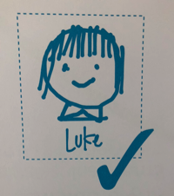
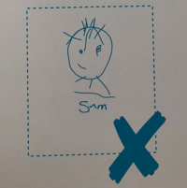
- Return your envelope to Mrs Thomas at the Early Years Gate before 9:00am Friday 5th November
Please – can you send your drawings back in even if you don’t want to buy a tea towel? It would be wonderful to have all the children’s drawings on the tea towels.

Please note – the tea towels are only being made in the Early Years and KS1. Further up the school they have already made them in previous years. Any questions please email: friendsofhothamschool@hotmail.co.uk
____________________________________________________________________
Draw here:
Order slip: £4 per tea towel
Name: __________________________
Class: Nursery R-Pondskaters R-Dragonflies

Number of tea towels ordered _____

Amounted enclosed £ _______________
[ ] Paid online on pta-events.co.uk/hotham
[ ] I have drawn my picture in thick black pen
[ ] We have added their name in the drawing. (We will add a first initial if two Bobs etc)

