Minutes of PTA Meeting
7th June 2018

Present:
Sarah Elliott, Claire Ing, Mel Hailstone, Emma Morrison, Val Hogg, Katherine Sargent, Mel Cooper, Sara Head, Joanna Michael, Amelia King.

Apologies Received From:
Izel Botha, Jacques Botha, Mark Jennings, Laney Fleet, Karen Leonard.

The meeting opened with a welcome and introductions from all present.

1. Agree Previous Minutes
The minutes were to be agreed as a true record of the meeting.

2. Treasurers Report
Account Summary

The account has available funds totalling £16,218.05 as of 5th June 2018. This figure includes £102.54 income anticipated from the Spring Ball 2018 Silent Auction but has not been received yet. At present, the account funds do not reflect the income raised from the cake sale (£205).

£15,453.57 of this is allocated to the reserve funds as detailed in the table below.

The total reserve budget of £17,358.44 for FY18/19 was agreed at the 26th April 2018 PTA meeting.

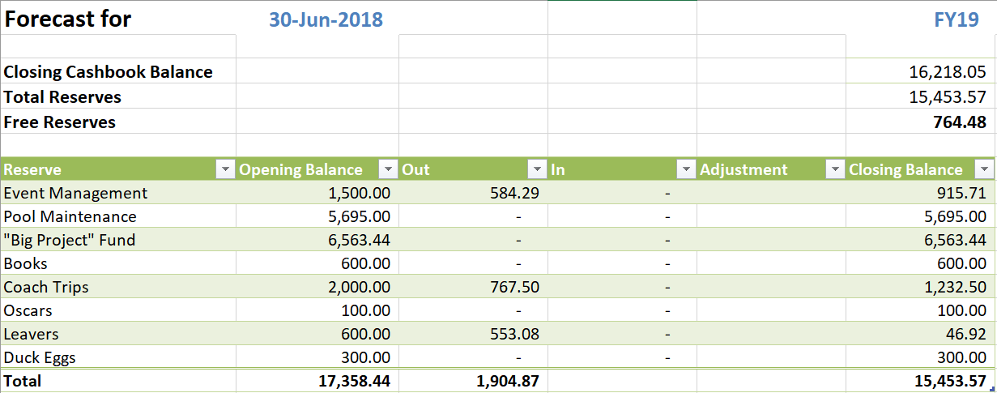

FY 2018/2019 Donations

Donations totalling £1320.58 have been made to the school during FY18/19 so far. These donations are detailed below:

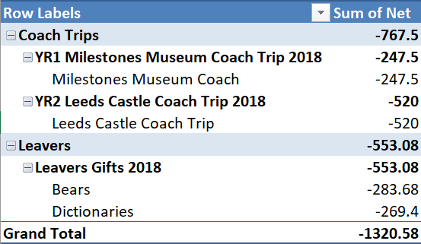

FY 2018/2019 Event Summary

Ecokids raised £112.50! Expenses totalling £284.29 have been incurred for the Summer Disco and Summer Fair. Details of all event transactions are detailed in the table below:

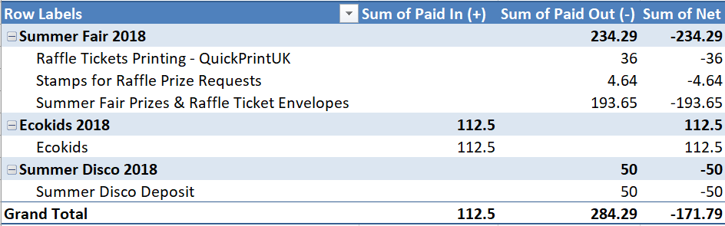

FY 2018/2019 Other Transactions Summary

FY18/19 transactions not attributable to specific events are detailed below:

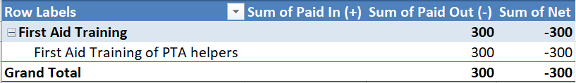

Other Notes for discussion at the PTA meeting on 7th June 2018

Circus Tickets –

My recommendation is a flat rate of £9/ticket (without food) with under 2’s free (must be sat on laps). I would suggest all tickets are sold on PayPal with compulsory fees. Prices with PayPal Fees included are detailed in the table below:
 | Price with PayPal Fees
5 Tickets | £45.83
4 Tickets | £36.70
3 Tickets | £27.58
2 Tickets | £18.45
1 Ticket | £9.33

To break even at £9/ticket, 356 tickets will need to be sold. If all 600 tickets are sold, a profit of £2,202 will be made.

3. Governors Report

The PTA was thanked on behalf of the Governors for their continued support of the school.

4. GDPR

There was some discussion surrounding the Whatsapp Groups/Facebook page and GDPR. The plan going forward is that the Facebook Page will be our main way of communicating our events and requests to parents. The second way the PTA will communicate will be via the PTA website and finally via Parentmail. It was also discussed that we as the PTA cannot request class reps send messaged via the whatsapp groups.

5. Event Updates

Cake Sale - The cake sale raised £205. Year 1 parents were congratulated and thanked for running it. It was said that it really helped to boost the PTA pot and this will be a continuing event with one cake sale per term. It was decided that Year 1 will run it again in the autumn term as this will be the current Year R and then will rotate from there. Each year group will be responsible for running their sale. Next sale planned for Sept/Oct 2018.

Splashtime - Karen Leonard has now received a Vodafone sim, so can finalise setting up the phone. She has spoken to Sarah Elliott regarding a start date and she confirmed whenever we are ready. She will message out to all the first aiders and start booking them in. After this we will advertise via Parentmail/Facebook. Aiming to start from Wed 13th or sooner! Will advise when ready to start.

First Aid Course - 6 attendees on the course and all have passed. It was mentioned that if the school run a course in the future could the PTA tag on to this but it was said there are no current plans to run any further courses.

Summer Disco - Laney Fleet has booked a new DJ and the deposit of £50 has been paid. Posters have been made and just need to be printed. Tickets are ready to go live tomorrow and glow items still need to be purchased. It was confirmed that Year R will be collected from their classrooms after their disco and Year 1 children will be collected from the hall. Tickets for the disco are priced at £4.50 which includes a snack/drink and glow items. Check how many helpers we need.

Leavers - Dictionaries and Bears have now been ordered. The wording in the dictionaries last year read "presented by Heather Ridge Infant School PTA July 2017". This year the wording suggested is "Presented by the Friends of Heather Ridge PTA July 2018". All present were in agreement. Sarah Elliott confirmed that she would need three helpers for the leavers event. Preferably Year 1 parents. Katie Chapman has been asked to do cakes/biscuits.

Circus - It was suggested that following a discussion with Mark Jennings and Claire Ing that the ticket price be set at a flat rate of £9. All present were in agreement.

Summer Fair - KL has the banner and is aiming to have this up by the weekend. Heatherside Preschool have asked if they can have a stall at the fair. If there are no stalls available it is suggested they could help to sell the canvass bags. There was a discussion surrounding the face painting. Seems too costly to hire someone in and our profit would be minimal. Amelia King to look into seeing if she can find some parents willing to volunteer. Sarah Elliott has been contacted by a past pupil who would like to run the Jam Jars. Mel Cooper has arranged a Mickey Mouse and Minnie Mouse suit for the fair. A donation for photographs will be asked.

Staff Helpers are:

Dagny Norman
Kath Galloway
Sue Henson (12-1pm)
Helen Jones (2-3pm)
Becca Waterfield (12-1pm)
Jo Ford (12-1pm)
Andy Fuller (12-1pm)

Year R staff have requested they help with the tea and cakes and are:

Debbie Crow
Laura Took
Charlie Williams
Annie Cullen (1-2pm)
Claudia Brooks

Summer Fair packs were distributed to class reps present at meeting and some resources for the fair was also given out.

5. AOB

- It was mentioned to do a PTA Coffee morning.
- Katherine Sargent has offered to speak at the new parents evening.
- Minutes still don't seem to be appearing on the PTA website.
- Discussed Signatories for the account. Mark to send email to CI and SE.
- PTA newsletter - another local school newsletter was shown and it was mentioned that perhaps we could follow their example.

All those that attended were thanked for coming.

If you have any new ideas for fundraising, please let any of the PTA Committee members know.

Date of Next Meeting: TBC but Early September

