Minutes of PTA Meeting
26th April 2018

Present:
Sarah Elliott, Claire Ing, Mel Hailstone, Emma Morrison, Laney Fleet, Karen Bell, Lisa Bolderson, Mark Jennings, Sylwia Sieracka, Val Hogg, Kirsty North, Nicky Barker, Katherine Sargent

Apologies Received From:
Jacques Botha, Laura Anderson, Lisa Glen, Katie Chapman

The meeting opened with a welcome and introductions from all present. It was re-iterated that the PTA is made up of those holding office (who are trustees of the charity) and all the parent body. The main objective of the PTA is to raise money in order to support the school. PTA meetings are open to all and there is no objection if people need to bring smaller children to morning meetings.

1. Agree Previous Minutes
The minutes were to be agreed as a true record of the meeting.

2. Treasurers Report

FY 2017/2018 Donations

Donations totalling £13,127.67 have been made to the school during FY17/18. These donations are detailed belo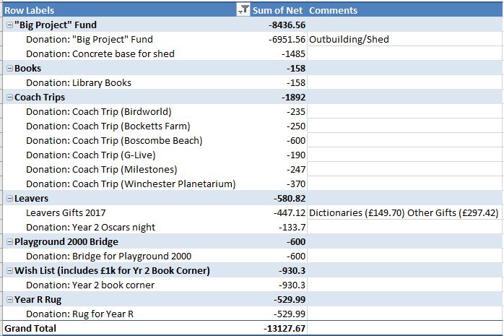w:

FY 2017/2018 Event Summary

PTA events held during FY17/18 have raised £9,335.95 as detailed below:

Event | Money Raised
Summer Fair 2017  - Sponsor  - Raised on the Day | £573  £3430.81
Summer Disco 2017 | £325.48
Splashtime 2017 | £716.15
Pamper Evening | £504.20
Pumpkin Hunt 2017 | £52.46
Second Hand Uniforms | £77.82
Ecokids 2017 | £158.40
Christmas Fair 2017  - Bridges Sponsor | £125.00
- Raised on the Day | £2440.58
Christmas Disco 2017 | £402.36
Christmas Cards 2017 | £183.56
Christmas Theatre 2017 - Woking | £114.79
Christmas Theatre 2017 - Camberley | £91.28
Mother’s Day Tea Towels 2017 | £20
Mother’s Day 2018 Canvas Bags | -£361.12
Quiz – Spring 2018 | £266.96
Easter Egg Hunt 2018 | £49.70
Spring Ball | £164.52
Total | £9,335.95

Items to discuss at PTA Meeting on 26th April 2018:

- Signatories for the PTA account to be agreed and the upper limit that any one signatory can sign for. See separate document for details.

- Reserve Allocations for the next FY. See below:

The account has available funds totalling £17,777.05 as of 24th April 2018.

The following reserves are proposed for the next FY as a starting point for discussion. The reserve allocation below would leave a further £5,518.61 available for allocation. It has been suggested that £5k of this is added to the “Big Project” Fund bringing the “Big Project” reserve up to £6,563.44.

Event Management | £1,500 | Identical to the amount allocated during FY17/18
Pool Maintenance | £5,695 | Balance carried over from FY17/18 reserve
“Big Project” Fund | £1563.44 | Balance carried over from FY17/18 reserve
Books | £600 | Identical to the amount allocated during FY17/18
Coach Trips | £2,000 | Uplifted from £1,892 spent during FY17/18
Leavers | £600 | Identical to the amount allocated during FY17/18
Duck Eggs | £300
 | £12,258.44

It was agreed in the meeting that Mark Jennings can sign cheques. It was also agreed that Sarah Elliott and Claire Ing to be signatories. Limit has been agreed at £1,000 for a single signatory. The current financial year has now ended and the budgets for 2018/2019 were agreed by all PTA.

3. Governors Report

The PTA was thanked on behalf of the goveners for their continued support of the school. The staff and pupils are enjoying the Learning Den and the Duck Eggs that have brought awe and wonder to the children along with all the other resources that the PTA give. The governors also want to take this opportunity to thank the PTA for all the events that have been done this academic year and all those that have been planned and to thank those that have taken time to attend this evenings meeting.

4. GDPR

This goes live on the 25th May 2018. We have been looking at the information we have, why we have it and where is it stored. Parentmail being the biggest issue. Every parent will receive an email to opt in for receiving PTA information. Whatsapp groups have also been mentioned. Mark Jennings been appointed interim GDPR compliance officer, although this is still under discussion, but as the school is under 250 pupils we dont have to have one.

5. Event Updates

Circus - Circus has been booked for Sunday 14th October. Once the tickets arrive we will put 2/3rds up for sale immediately and retain a 1/3 for sale once the new Year R start in September.

It was suggested that we look into the possibility of a local cake maker to make a circus themed cake to raffle off.

Duck Eggs – All the eggs hatched and were all doing lovely. Ducklings due to be collected 27th April.

Spring Ball – Was a stressful event and Katie Chapman and Laney Fleet did an amazing job. The silent auction raised £348.54 and all money to be collected by 1st May 2018. Thanks to Pine Ridge for their generosity.

The question was raised as to whether it was to be an annual event and it was discussed as to whether to book again now so that people have the dates in their calendars early.

Easter Egg Hunt – Raised £49.70. Since Mel Cooper took over the Easter and Halloween hunts we have received a profit from these events.

Quiz Night - 46 people attended. Mel Cooper supplied the food from Oysters Fish and Chips and although the food didn't make much profit it added to the night in a positive way. The event raised £266.96. Dagny Norman also donated her winnings back to the school.

Shopping Bags – Currently at a £361 loss. Discussed the possibility of reducing the price or offering a deal for the summer fair. Kirsty North said she is happy to run a stall to help to sell some more and the possibility of the school council being able to help with this.

Summer Disco – It was discussed that a committee needs to be formed. Laney Fleet has offered to be the coordinator for Year R and Sara Head has been volunteered for Year 1. Claire Ing to speak with Katie Chapman regarding the DJ's. Agreed we will need 12 volunteers to help at the disco and 2 first aiders per year group.

Splashtime/Swimming - Letters are ready to go out and will need volunteers. The volunteers must have a current DBS. We need a minimum of 5 helpers per session for Year 1 and 2 and a minimum of 8 helpers for reception. Mel Cooper happy to organise helpers. After half term splashtime will run every afternoon and the 1st two weeks of the summer holidays. Two first aiders will be needed per session. There is a 20 child limit for each session. Maximum age limit is 10 years. Under 4's can be accommodated but a parent will need to be in the pool with them. Splashtime raised £716 last year and it was also discussed about the possibility of ice cream sales after school. It was raised about the possibility of parents booking via the PTA website but it was deemed not feasible to do this.

Summer Fair - List of stalls to be distrubuted to class reps to find volunteers. Ideally we need 3 shifts per stall of 1 hour each.

Panning for Gold - Jellyfish
Crockery - Katherine Sargent

Drinks Tombola - Kirsty North & Dolphins
Beer Tent/Food - Nicky Barker

Claire Ing to contact after school clubs about the possibility of doing an arena display. Also Claire Ing is organising raffle prizes.

First Aid - We need to check availability and work out a time.

5. AOB

Leavers Gifts - All agreed for Karen Bell to go ahead and purchase the leaving gifts of an Oxford Dictionary and the Heather Ridge Bear at a total cost of £583.80. Leavers books will require someone to coordinate. It needs to be a Year 2 parent but to request assistance from Year 1 so they know what to do next year.

Oscar Night Donation - Jacques Botha will do the photographs and Lisa Bolderson has donated a flower garland. Sarah Elliott requested £100 for oscar night and PTA all in agreement.

All those that attended were thanked for coming.

If you have any new ideas for fundraising, please let any of the PTA Committee members know.

Date of Next Meeting: 7th June 9-10am

