Minutes of PTA Meeting
11th January 2018

Present:
Izel Botha Sarah Elliott Claire Ing Katie Chapman Nicky Barker

Apologies Received From:
Lisa Gill, Mark Jennings, Joanna Michael, Jacques Botha, Melanie Cooper, Mel Hailstone, Preety Hanzra, Mandeep Harash, David Davies

1. Agree Previous Minutes
The minutes were agreed as a true record of the meeting.

2. Treasurers Report
Event Summary

Assuming that all event expenses have been submitted, £4100.35 has been raised since the start of the 2017/2018 school year. The amounts raised by each event are detailed below:

Event | Money Raised
Pamper Evening | £504.20
Theatre - Woking | £114.79
Theatre - Camberley | £91.28
Xmas Cards | £183.56
Second Hand Uniforms | £38.72
Pumpkin Hunt | £52.46
Ecokids | £158.40
Christmas Fair | £2554.58
Christmas Disco | £402.36
Total | £4100.35

Notes
- The money raised for the Pamper Evening is £10 greater than previously reported due to the omission of a table booking fee.

Account Summary

The account has funds totalling £21,755.49.

£13,731.32 of this has already been allocated as detailed in the table below.

This leaves £8,024.17 of free reserves that are available for allocation.

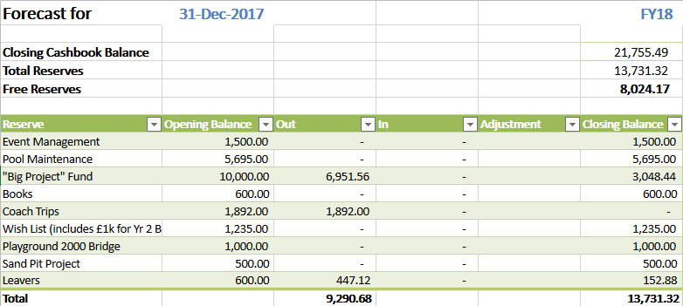

Notes:
- £6,951.56 of the £10,000 “Big Project Fund” has been spent on the outbuilding. An invoice is expected from the school for the concrete base which will be paid from the £3,048.44 remaining in the “Big Project” Fund.
- £1,892.00 has already been donated to the school for coach trips. This was uplifted from the original £1,850 budget as agreed at the last PTA meeting.

3. Governors Report

-

4. Event Updates

Pancake Club – As this falls in half term we have decided to cancel this for 2018. To run before would be too early and the school hall will be out of action the week after half term due to ceiling replacement.

Grandparents Morning – Will be on 9th February from 9am – 11am. We will require a minimum of 4 helpers to man the refreshments. Claire Ing to arrange hot cross bun donation from Sainsburys and to contact Waitrose to see if they can donate a voucher.

Quiz Night – Date to be 2nd March. Tickets will be £5.00 per head and participants will be allowed to bring their own food/drinks/alcohol. Izel to speak to Melanie about the possibility of fish and chip suppers to be delivered in at an extra cost. These would need to be purchased in advance via the PTA website.

Easter Extravaganza/Egg Hunt – It was decided to combine the two events and to have one Easter Egg hunt to be held after school on the 29th March. Melanie Cooper to coordinate. We will invite the Easter Bunny.

Mothers Day – Shopping Bags are currently in the process of being ordered. Karen is coordinating this.

Ecokids – Was really successful last time so looking into the possibility of running again in May. Emma Morrison to be approached to organise.

May Ball – Katie to investigate and look into venue/cost, and judge interest and viability.

Summer Disco – TBC

Swimming Lessons – Last 6 weeks of the term. Each year group has 2 lessons a week and we require 5 helpers per year group, all need to hold a current DBS and one of which is required to be first aid trained.

Summer Fair – Provisional date of 30th June has been arranged.

New Start Induction – July/Early July- Helpers will be required to run refreshments/second hand uniform.

Splashtime – Will be running the 1st 2 weeks of the summer holidays (1-4pm) and after school after the June half term (3-5pm). Volunteers to run will be required for this.

5. AOB

It was raised that there would be some interest in a day for dads/father figures. Sarah Elliott to have a think and look into the possibility of doing something.

First Aid Courses – have a few quotes already for running a course but looking into further training providers and need confirmation of numbers.

Christmas Disco was discussed and decided that going forward a School Disco Committee will be created to ensure the smooth running of future events. There were some issues that arose at the Christmas Disco and until we can be sure these will not happen again and plans put in place we are not in a position to arrange a date for the summer one. Looking into a new DJ for forthcoming events.

It was suggested we investigate again the Circus for Schools. Claire Ing to do some research and to come back with costs/availability.

Sarah Elliot thanked the PTA for the money received for the learning den and has put in a request for funds for some furniture to go in it.

Year R document – it has been discussed and approved that we will put together a document for Year R Parents to help them understand requests and events etc. A list of dates will be put together and a document formulated and approved prior to September 2018.

GDPR - General Data Protection Regulation (GDPR) – is a new EU law governing data protection, which will supersede the Data Protection Act in 2018.

There are strict controls imposed on “data controllers” and “data processors” which will affect the way the PTA uses members data. (Specifically, around Personal Identifiable Information: PII)
“There is no significant charity exemption to data protection” – so it essential that we are compliant by the 25th May 2018. (Strict penalties are in place if we are not compliant). Jacques Botha to investigate and help PTA to be compliant by 25th May 2018.

If you have any new ideas for fundraising, please let any of the PTA Committee members know.

Date of Next Meeting: 22nd February 9am-10am

