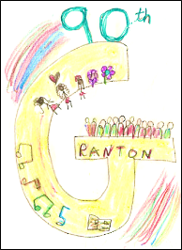

Granton PTA will meet Wednesday, 14th November 2018 from 7pm at Signor Ciccio. (SW16). Apologies should be recorded with Fi Macnab. Please notify the Chair (in advance of the meeting) if you have any items under AOB. Thank you.

Agenda
- Apologies
- Approval of Previous Meeting Minutes
- Actions / Matters Arising from previous meeting

- Treasurer’s Report
  - Holiday Cards Fundraiser

- New Business

- Upcoming Events
  - Winter Fair - 24/11, 1-4pm
    - PTA Stalls
    - Estate agent boards & Vol Coord (NG)
    - Shopping & supplies (AL)
    - Year 6 stall (ND)
    - External Stalls (LRR)
    - Silent Auction (KW / LRR)
    - Sponsorships (MH)
    - Entertainment & contracted services (KW)
    - Programme (KW)
    - Cash Float (LRR)
  - Winter Disco - 07/12 6:30 - 8pm
    - Lead (FM)
    - Tickets (remaining sold online after in-person sales at Fair)
    - DJ - volunteer secured
    - Volunteers for snack bar, glitter tattoos, Door
  - Second Hand uniform sales
    - April?

- Any Other Business

- Date / Location of next meeting - Sat, 19th January 10am, Granton Primary School

