COLOUR RUN INFORMATION PACK

This information pack contains all the important information you need about this event which takes place on Sat 11thMay at Three Rivers Academy, Hersham Road, Hersham,Walton-on-Thames, KT12 5PY.
Please take the time to read it carefully to ensure things run as smoothly as possible for everyone on the day. If you have registered on behalf of someone else please share this information with them.
TIMINGS
Gates will open at 9.30 AM
Please report to the Registration Desk upon arrival. This will be in the Main Hall in the Teal Coloured section of the school. It is sign posted ‘Community Entrance’. Here you will pick up your race number and running pack. To avoid any problems/delays bring along your original confirmation email with you (paper copy/or on your phone).
Can’t find it? Try searching your junk mail or email friendsofTRA@hotmail.com and we will resend.
10.30 Warm Up
10.45 Start of Run
RUNNERS PACK
Contents include:
Cotton Shopper Bag Large white T-shirt (smaller sizes will be supplied for under 12s) 100gm pack coloured powder Wristband Running Number & safety pins Finishers Medal (to be collected at the end of the race)

PERSONAL POSSESSIONS
Do not leave any personal possessions unattended. If you’ve not got a spectator with you to look after any belongings, at your own risk, you can leave them with us in your runner’s bag and reclaim them after the run.
THE COURSE
Around the course our Colour Bandits will shower you with coloured powder at each of our 4 Colour Stations…these will be at approx. 1km intervals.
As you head for the finish spectators will join in the colour throwing fun.
The dye is bio-degradable but please refrain from throwing outside of the course area.
WHAT TO WEAR
All pre-registered runners are supplied with a white T-Shirt but you can wear your own if you prefer. Just remember whatever you wear will get covered in coloured dye and while it’s designed to be washable, we don’t do your laundry…so wear stuff you don’t mind getting a little colourful and that includes your trainers. You may not be quite ready to toss those brand new trainers in the washing machine just yet!
If you’re driving home after we recommend bringing towels to cover your car seats.
SAFETY
Use common sense when throwing dye: The powder is non-toxic but don’t throw directly into peoples’ faces. You may wish to wear sunglasses to prevent it getting in your eyes. Do not throw dye at photographers with expensive equipment.
Drink plenty of water. Bring your own bottle to stay hydrated during the event.
REFRESHMENTS
Mobile Coffee Van serving hot and cold drinks, cakes & biscuits…and smoothies if hot.
Wood Fired Pizza from the
BBQ
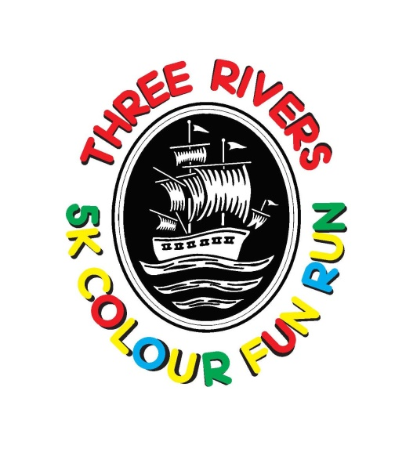
SPECTATORS WELCOME SO BRING YOUR SUPPORTERS TO CHEER YOU ON !

