FOSG Meeting _13/07/2021
Attendees: Tracy Hobson, Kate Witkiss, Tony Storey
Apologies: Toni Rowson, Emily Robson, Caroline Moses, Katherine Norris, Claire Rowson
Minutes from the last meeting: Still outstanding

Finance update:
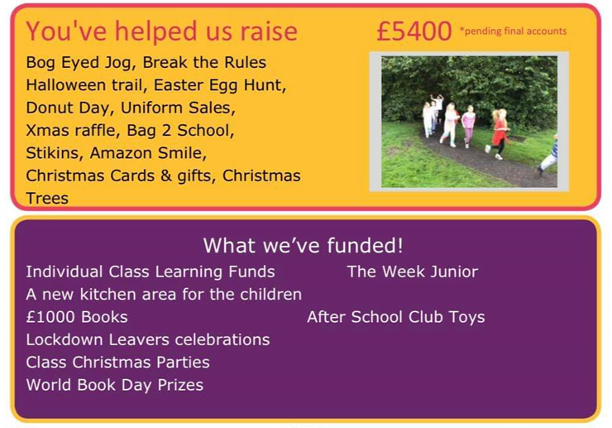
Overall bottom-line profit after all expenses = £2366.16.
Our best event was the Bog-eyed Jog (£2,219.80 raised after cost) and the Christmas raffle was the best conversion (outgoings £8.65 vs incoming £1165) NB School did not do their raffle this year which could have helped, plus a lack of events due to covid.
Biggest Expense- class kitchen- FOSG are quite disappointed there has been no feedback from school since this was installed.
Pre- loved – currently about £400 but still have the stall to go
Colour run money is also still to come in and the Summer raffle sales
Actions: Try over the summer to remove Caroline from the finance books and add Tony so he can access the finances fully- struggled this year.

Main discussions:
Raffles going forward: possibly get a licence to be able to sell tickets to the wider community. It needs to be investigated, but Kate thinks we need to have printed tickets and provide a Financial breakdown to the council. The later is easy enough but the cost of printing tickets might make the event less profitable.

Newsletter – We discussed sending this to our PTA families direct using the FOSG email rather than relying on school. The PTA app does have the option to send newsletters too. If it went through the app we are GDPR compliant and permissions are confirmed through the system. Look to do this next year and see if it works.
The minutes form the meetings should also be added to the PTA app from September for ease of access to all our parents.

Token system – As we have a card machine can we set up the option for parents to pay on card and use tokens at events/stalls. This might promote more sales as parents do not just have the cash in their pocket and will remove any concerns of children carrying cash and less cash being held on site. Cash would still be accepted too.

New committee members – We need a few more people for the committee going forward (at least 2 for AGM). Kate has made a few initial contacts, but we also have the new starter form from the last 2 years that we have not utilised and the intake for September 2021 has not yet been shared by school. In September we need to contact these parents and get them involved. Maybe run a Coffee morning in school – come and meet FOSG, get involved, what we do and the different roles etc.

Next year:
Some possible events for next year if Covid allows-
- Bog eyed jog- booked for 23rd Sept
- Halloween party or family event
- Shall we change the Christmas cards and do t-towels instead? We could not decide so going to put it to a parent vote on FB. If we register for both and then put the vote out over summer as we need to know by 1st week in September so the artwork can be completed in class.
- Christmas fair and markets- Mr Darbyshire asked if the market stalls were an idea for this year at the Christmas fair on the playground. Kate is concerned, from previous experience, they are a lot of work for not a lot of income and the stall holders get very little sales. But spreading the fair to outside as well would create more space and maybe running it on a Saturday so it is not as busy would be better in a covid world.
- Look at doing a Christmas shopping evening and/or a fashion show- both successful events in the past.
- Summer fair ideas for next year- based on the last 2 years we should plan a big summer fair event and hope the restrictions are at a low level and outside events are allowed. Possible activities include Nerf wars, all 999 services, Battlefield live (although some of the ‘guns’ are very realistic, might be inappropriate).

Meetings going forward:
We need to look at running Hybrid meetings for FOSG ideally via Microsoft Teams. Meetings still to be held face to face at school but those who can’t make the meeting can log on , screens can be shared and votes etc. Plus there is no time limit like on zoom. This would open up the committee to more parents too.
At the next AGM we need to update the Trustees as this wasn’t done last year. We also need to take Mrs Robinson off and add Mr Darbyshire.

Special Thank Yous:
Unfortunately Helen and Katherine couldn’t make this meeting tonight but all of us would like to say a huge thank you for all the years of support, ideas, time and laughs. Katherine gave 3 years and Helen a massive 10 years. Thank you to you both, we will miss you but wish you all the best for the future.
Also a massive thank you to Kate for organising everything this year in a very testing time. This year would not have been as successful without you.
AOB:
We are going to try and arrange FOSG drinks one night over summer as we haven’t been able to meet up for such a very long time. It would be nice to give Katherine and Helen a proper send-off too.
Next Meeting:
September 2021

