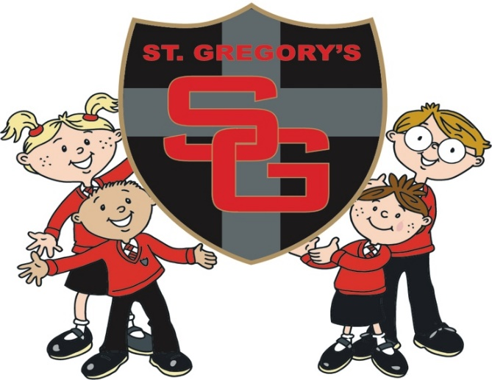
Friend’s of St Gregory’s Bog Eyed Jog 2020
Sponsorship and Gift Aid declaration form
Please sponsor me (name of participant) __________________________________________________________________________________To (name of event) __________________________________________________________________
In aid of (name of charity) ___________________________________________________
If I have ticked the box headed ‘Gift Aid? √’, I confirm that I am a UK Income or Capital Gains taxpayer. I have read this statement and want the charity named above to reclaim tax on the donation detailed below, given on the date shown. I understand that if I pay less Income Tax / or Capital Gains tax in the current tax year than the amount of Gift Aid claimed on all of my donations it is my responsibility to pay any difference. I understand the charity will reclaim 25p of tax on every £1 that I have given.
Remember: You must provide your full name, home address, postcode & ‘√’ Gift Aid for the charity to claim tax back on your donation.
Sponsor’s Full Name  (First name & surname) | Sponsor’s Home address  (only needed if are Gift Aiding your donation. Don’t give your work address if you are Gift Aiding your donation.) | Postcode | Donation Amount £ | Date paid | Gift Aid? Please √
Sponsor’s Full Name  (First name & surname) | Sponsor’s Home address  ( only needed if are Gift Aiding your donation. Don’t give your work address if you are Gift Aiding your donation.) | Postcode | Donation Amount £ | Date paid | Gift Aid? Please √
Please return all sponsorship money by Friday 9th October 2020

St Gregory’s Bog Eyed Jog 2020
Information for the Day
Thursday 24th September 9.15am

We may have had to postpone it in May but Covid will not stop us from putting on the children’s favourite event of the year !! however there will be some small changes to allow us to stick to the guidelines and keep everyone safe.
The Bog Eye Jog will be staggered and done in bubble groups rather than the whole school. Post run snacks will be served in classrooms.
Approximate run times are as follows:
9.15 - 9.45 Year 6
9.45 - 10.15 Year 5
10.15 – 10.45 Year 4
10.45 - 11.15 Year 3
11.15 - 11.45 Year 2
1.15 - 1.45 Year 2
1.45 - 2.15 Year 1
2.15 - 2.45 Reception

- Arrive at school at your normal time in your pyjamas and trainers (or wellies if it’s wet)! Complete the minimum amount of laps for the year group (as stated below) within 30 minutes.
- Collect sponsors from family & friends (you can collect before and after the event). Minimum of one sponsor per child is required. We are also trying to get a FOSG Just giving page set up in time to allow for online sponsorship too. Keep a watch on facebook for updates
- There will be prizes for those who collect the most sponsorship.
- After the Bog Eyed Jog all school children will be provided with a tasty snack Children can spend the day in their pyjamas.
- Please note this will still go ahead if it is raining, please ensure suitable footwear and coats are provided. You may also send spare clothes/PJ’s to change into if it is wet.
- At the time of writing this, unfortunately we are not allowed to have any parent spectators this year.
- Every penny raised will go towards FOSGs
- Friends of St Gregory’s will provide a snack for all school children taking part.
- Please let us know a minimum of one week in advance if your child has specific dietary requirements or if you have any additional questions by emailing
fosg@st-gregorys-pri.lancs.sch.uk
Minimum Laps Required
Reception – 6 laps KS1 – 8 Laps KS2 12 Laps

