FOBS Minutes
9 March, 8.15pm
Attendees
Roz | Pierette
Carla | Sharon
Katinka | Samantha
Caroline | Alex
Marion  Jo  Ash | Jyoti  Talitha
- Apologies given – Vicki, Sarah
- Previous minutes accepted by all
- Introductions – We all know each other, introductions not needed
- Financial update.
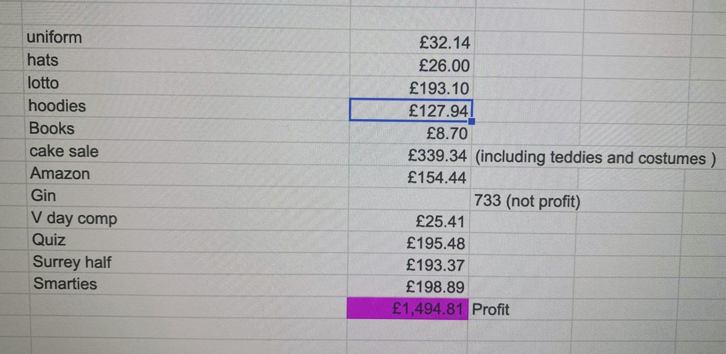
From September we have made approximately £11,000 in profit.
- Feedback of Current Events
  - Year 5 Cake Sale
    - Cuddly toys sold quickly, but there are still more left in the shed.
    - Not many books sold (£10), but it has decreased our stores
    - 50% costumes sold on the day (£40) and the rest have been sold online – thank you Jo and helpers!
    - More eco-friendly using paper bags and encouraging families to bring their own Tupperware
    - Suggestion to encourage further families to bring their own tupperwares by giving them 3 cakes if they do so (2 cakes if they use one of our paper bags). To be considered.
  - Silver Smarties
    - Sold all 180 tubes, got back 60
    - £260 profit
    - Include in newsletter that we are still receiving smarties tubes and happy to still take them. – Action MB and CA
  - Bisley Gin
    - 40 bottles sold.
    - 39 bottles sold on the early bird offer
    - We have order 150 bottles so in order to continue selling them we need to find a premises to sell them from or we host an event for which we need a licence to sell them there.
    - Sam happy to ask in the Hen and Chickens if they might store for us. Should be 110 bottles approx. Jo to check with Hare and Hounds if Hen and Chickens say no. Action SP and JV
    - Profit margins are not large, approx. cost per bottle £28.20
    - We need a ‘Free House’.
    - Update: Sam has an agreement in principle from the Hen and Chickens
  - Mother’s Day
    - £1,900 of orders taken. Profit to come, but more money spent than Christmas Cards.
  - Fish and Chip and Quiz
    - Thanks to Sam for organising on the day and to Sarah for her behind the scenes organising.
    - Would be nice to recruit more non-FOBS member teams.
    - We need a tie breaker question prepared in advance.
    - Great to have staff picture round, but maybe to award fewer points as it is hard for Reception or KS1 children’s parents.
    - Prizes for 2 and 3 place?

  - Surrey Half Marathon – 5 March 2022
    - Thank you to the runners and supporters too!
    - Around £1,400 raised so far.
  - Eco Project
    - 747 bottles so far, we are halfway there: amazing!
    - We are struggling to work out where we are going to place the greenhouse, more updates soon.
    - Discourage people from bringing in squashed bottles or the wrong size – must be 2L bottles. – Action for Newsletter CA and MB
  - Year 6 Hoodies and Leavers’ Books
    - Jo is storing the hoodies which have arrived.
    - Hoodie World have been great, really fast responses and less than 2 weeks between ordering and delivery
    - Kids will get their hoodies tomorrow.

- Times and Dates of future Meetings
  - 25 April
  - FOBS Social: Nags Head 25 March TBC.
- Future Events
  - Happy Bags
    - Sorted for the 23rd
    - Newsletter made it clear what was required, thanks to Marion and Caroline.
  - Easter Egg Event
    - We have almost all Easter eggs, waiting for free from eggs to be on special offer.
    - Pierrette is double-checking the allergies, school to email the list over to her.
    - Children with any allergy will be given a ‘free from’ egg unless they contact us. This message will go out on rep groups. Action PDV
    - £76 taken already
    - Pierrette has requested volunteers: Alex to assist.
  - Rabbit ramble
    - Jo organising
    - People pay for their rabbit ramble map on PTA events which is then emailed to them.
    - Rabbit pictures displayed in houses around Bisley, in and around Flowers Estate only which makes it a manageable walk.
    - Perhaps a colour theme: find the red rabbit, blue rabbit etc.
    - Some rabbit ears left over from last time which we can sell on PTA events as an additional purchase.
    - Jo would like to offer the children a chocolate egg for finishing the ramble, but ideas welcome as to how to do this (not everyone will do the walk on the same day.
  - Year 4 Cake Sale
    - 1 April after school (early pick up as last day of term).
    - To include uniform, especially Summer items?
    - We need to remind people to donate their unwanted summer uniform as our stocks are low. Include on Newsletter Action CA and MB
    - Katinka and Caroline to organise
  - Queen’s Jubilee
    - We cannot participate in our current company’s event items for the jubilee as we have missed the cut off.
    - Talitha researching if there are any other companies offering similar. Action TS
  - Eco Mufti Day
    - 22 April
  - Year 3 Cake Sale
    - 20 May
    - Pierrette and Roz to organise Action RB and PDV
  - Tea Towels Project
    - We need to choose Queen’s Jubilee or separate tea towel project or this is too many projects. To be revisited.
  - Painting and Prosecco
    - 21 May? To propose to Mrs McConnell
    - Katinka looking into a facilitator Susan Bench and find out how many she could facilitate as evening for. Action KC
    - Caroline asking Geeta Bhana if she may be available too. Action CA
    - Using the school hall? Any other suggestions of venue let the committee know.
    - Caroline, Katinka and Carla to organise.
  - Murder Mystery
    - 2 July
    - Not a formal play, a funny, family friendly event
    - Have a different meal other than fish and chips?
  - Wimbledon Mufti
    - Kids dress in sports clothes
    - Table tennis in the hall
    - Strawberries and cream and non-alcoholic Pimms sale.
  - Summer Auction/Raffle
    - We still have no volunteers to organise this.
    - To go to the wider group Action RB/PDV/CB
  - Gin Bar/Strawberry Fair
    - Marie Mendis keen to go ahead and liaising with the organiser. Action MM
  - Coin placing
    - 55th birthday of our school in June.
    - Mrs McConnell has agreed with Pierrette a little fundraiser.
    - Print out large letters to spell ‘BISLEY 55’
    - Each year group get s letter/digit to cover in coins.
  - Friday Freeze
    - 17 June or 1 July
- Other ideas to discuss
  - Father’s Day needs to be added
  - JV suggested serving refreshments at Sports Day including ice lollies
  - Colour Run?
    - Company called running ink who give you corn starch based colours
    - Asking everyone to raise £10 in sponsorship and you get white tshirt, sunglasses etc in a goody bag.
    - Obstacle course with throwing station and 2 lanes, one for those who do not want to be ‘targets’
    - Possible September date
    - Would we need to clean the field we use?
    - School field or ask to use the rec. School field means we have school facilities to use too.
    - Could sell extra packs of paint?
    - To talk this over with Mrs McConnell with full details available of what we are proposing Action CB
- Any Other Business
  - Comic Relief
    - More volunteers needed to collect money on 18 March
    - Thank you to those who have already volunteered.

MB

