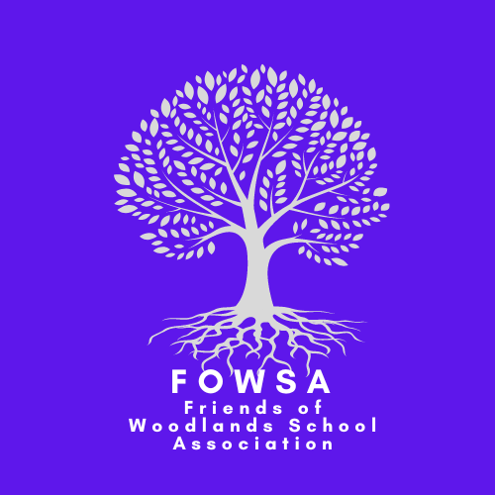

Minutes of the Meeting – 22.2.23

Present – Claire (Co-Chair), Suz (Co-Chair), Mel (Vice Chair), Sharon (Treasurer), Jamie, Joe, Sarah, Nicola

Apologies – Vicky (Secretary), Lou, Lisa, Nicola, Michelle, Laura, Verity

Order of business
- Discussion about Summer Fair 1st July 2023 11am-2pm
- Quick chat about Bingo event

Headlines for Summer Fair:
- Summer Festival Theme – Need to come up with an appropriate name.
- External stalls- put feelers out. £20 a stall plus raffle prize
- Charge for entry?? – Nicola suggested giving each child a book of tickets which they sell for an nominated amount, this ticket then gains entry to the fair and tickets sold are placed into a draw for a prize?
- FOWSA to sort BBQ (burgers, hot dogs, drinks)
- Ask Ash (Squirrel Coffee) to attend – Mel to Speak to Katie
- Ice-cream van – Sarah to sort
- Wood fired pizzas – Claire to sort.
- Investigate new carnival type games for fair – suggestions to be put forward.
- Contacting local businesses for prizes – Sarah to sort.
- Poster/ Flyer to be made for external stalls– to be sent to Formby bubble, put up around the village and school – Suz to make.
- Joe offered use of his van for transporting things.
- Claire suggested large balloon arch (colourful) – Sharon to ask Lizzie (three bears balloons)
- Steel drum band ??
- Need an MC - Mr Stix a possibility bringing along his circus skills too – Sharon to investigate cost, availability etc.
- Leis could be given on entry or as a prize
- Costume parade – register at 12 and parade at 12.30. Prizes for best festival based outfits.
- Each class to decorate a table for the fair, festival inspired – prize for best?

Suggested stalls:-
- Mocktail bar – would need to buy mason jars in advance. Claire suggested Home Bargains??
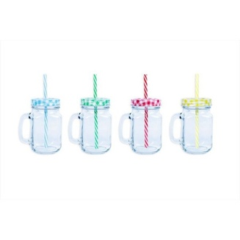
- Chocolate Tombola
- Bottle / Alcohol Tombola
- Teddy Stall
- Candy Floss – would need bags, sticks, sugar, colouring
- Beat the Goalie
- Glitter Tattoos / Hair braiding
- Coconut Shy – Sharon to see Rhona at Cassidy’s to order coconuts and to google rules for the game. Perhaps only need 3 coconuts and prizes are coconut related??
- Pick a pot / envelope
- Duck race – prizes small squirty guns
- Competition tent – children to bring in entries e.g., best lego model, best painting, best baking, best drawing, best craft etc. 50p an entry. Prizes for 1st, 2nd and 3rd.
- Hightown archery / paintball guns at target – to be investigated further
- Make your own fruit kebab / strawberries and cream
- Bottle ring toss
- Teacher in stocks – Mr Williams has agreed. Timed slots throughout the day.
- Fruit toss
- Steam train

Inflatable ideas:
- Caitlin’s Castles for Inflatable Obstacle Course – have we used this enough?
- Inflatable zorbs or something similar – needs to be investigated further
- inflatable nightclub - Sharon to contact Jade

Headlines for Bingo Event:-
- Entitled “Best of British”
- Need to check gambling licence – Sharon to check and feedback.
- Decide on an entry price and what it includes
- Mufti Day 28th April
- Sales open 13th March – 5th May

