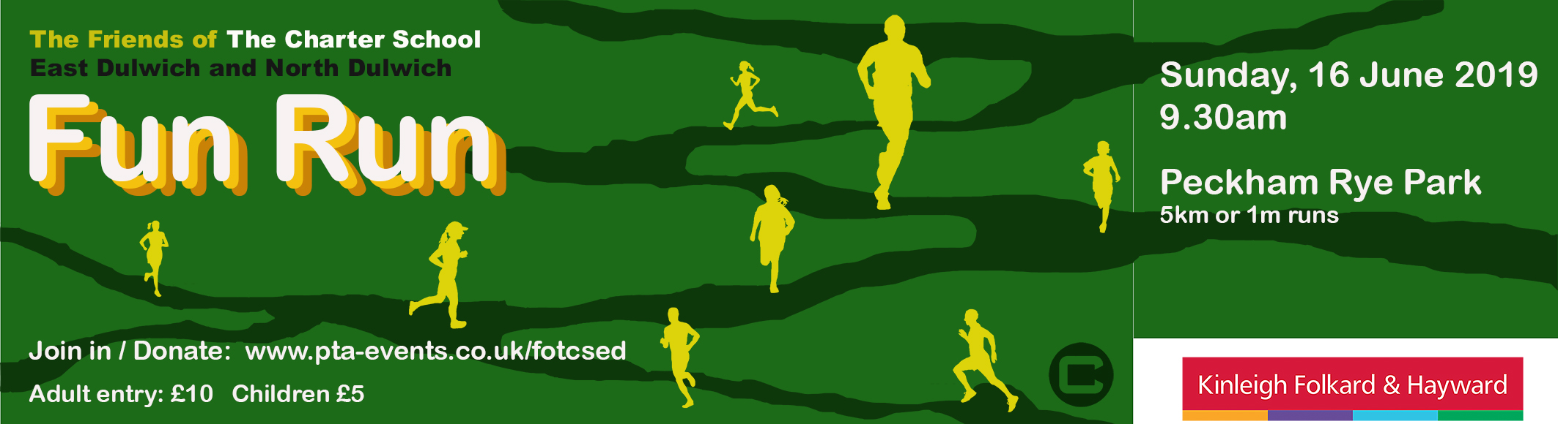

It’s time to raise lots of money for the schools!

Thank you for signing up for

The Friends of The Charter School East Dulwich and North Dulwich

FUN RUN

9.30am, Sunday, 16th June, Peckham Rye Park
for 1 mile or 5km runs

It’s going to be an amazing day!

Now it’s time to get everyone you know to sponsor you

HERE’S HOW YOU CAN DO IT...

OPTION 1

Donate directly via the PTA Event link HERE

https://www.pta-events.co.uk/fotcsed

Simply select the amount you’d like to donate in the ‘Sponsorship/Donations’ box.

OPTION 2

Use the sponsorship form on the back of this letter.

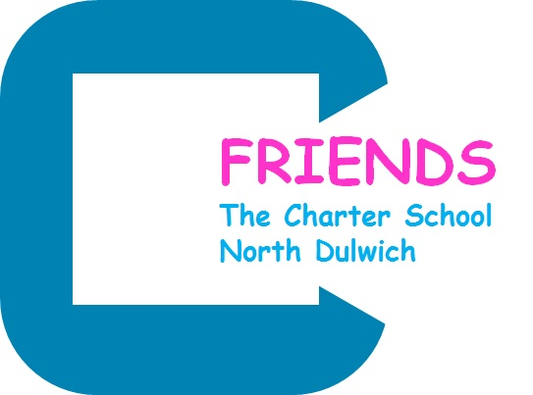

FUN RUN Sunday 16th June, 9.30am at Peckham Rye Park

First Name:__________________________ Last Name: _______________________________

Fun Run Entrance Number: __________________________

Dear Potential Sponsor,

I am participating in The Friends of The Charter School East Dulwich and North Dulwich Fun Run. All proceeds will help fund learning and enrichment projects for the students of the schools.

Thank you.

Name of Sponsor | Sponsorship Amount | Paid (Yes / No)

Participants:
Once your sponsorship money has been collected, please return this form to your teacher with your sponsorship money in an envelope clearly marked FUN RUN SPONSORSHIP.
Good luck!

