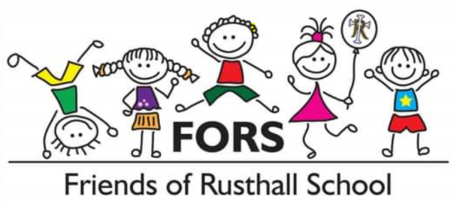

Social Media Rules/Policy for Friends of Rusthall School (FORS)

Welcome to our Facebook, Instagram and NextDoor Group and thank you for being a part of our wonderful community. We hope you enjoy our groups and we encourage your activity within. Please come by and take a look when you get a chance. Thank you.

Purpose

The purpose of our page/group is to provide an online community for parents and families of Rusthall CEP and residents within Rusthall Parish and surrounding areas.

Goal

To share information and tips, update the community on events and programs, promote Rusthall CEP and showcase the achievements of students, teachers, parents, and other community members.

Community Rules

- We encourage you to ask questions and share information. We request that you keep discussions focused directly concerning our school and community. All user posts will be submitted for administrator approval prior to being posted in to the group.

- We encourage posts that highlight our community’s accomplishments and constructively raise issues for discussion.

- When posting, please use appropriate language. Children can see our page. Swearing and any form of bullying, harassment and/or discrimination of any kind is strictly forbidden and will be subject to moderation by the admin team.

- Please DO NOT post identifying photos of your children. Do not post photos of other children. If you have any questions about posting a particular photo, please check with the administrators.

- Do not post about concerns, problems, or conflicts with individual teachers, administrators, students, or parents. We will immediately delete posts that in any way put down or discriminate against individuals.

- Online threats will be taken seriously, and proper authorities will be immediately notified.

- Do not post information commonly understood as confidential, such as student grades or any other sensitive information.

- Any inflammatory statements that make allegations against individuals or organisations will be deleted.

- Keep in mind what you post is public information and will be in the public domain.

- Any advertising for businesses is not allowed.

- Do not publish content as your own that has been created by others. Give appropriate credits if you do.

The FORS Officers and social media administrators reserve the right to delete comments and block users who are not following the rules stated above.

Contact Details

Email: fors@rusthall-cep.kent.sch.uk
Facebook: https://www.facebook.com/groups/1485132945094254/?ref=share
Instagram: (To be created)
Rusthall Next Door: (To be created)

