FOPS Annual General Meeting
Date: 25/09/2020 |  | Time: 19:45 | Location: via Zoom
Chair | Katy Bateman and Sarah Hawkins
Minute Taker | Anna Manlow
Attendees | Katy Bateman, Sarah Hawkins, Anna Manlow, Lorelei Phillips, Jacqui Chapman, Dan Edwards, Jen Edwards, Sam Miller and Kat Hefford
Apologies | Kate Mansell, Vickie,Christine Curtis,

- General –
Discussion | It was agreed that Katy Bateman and Sarah Hawkins will continue on as co-chairs of Fops, Anna Manlow will continue on as secretary and Lorelei Phillips will continue on as treasurer of Fops. This was agreed by everyone on the Zoom call.  No one else has shown any interest in these positions.  Sarah and Katy gave an introduction into who and what FOPS are as we have some new committee members.
Actions |  | Allocated to | Deadline
No Action

- Annual Treasurers Report - Lorelei
Report Summary | Below is the treasurers report for the Year September 1st 2019 to August 31st 2020  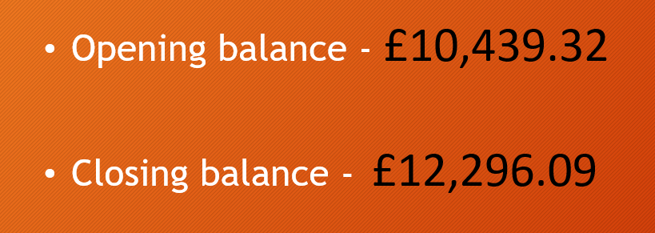  Below is the income for the year  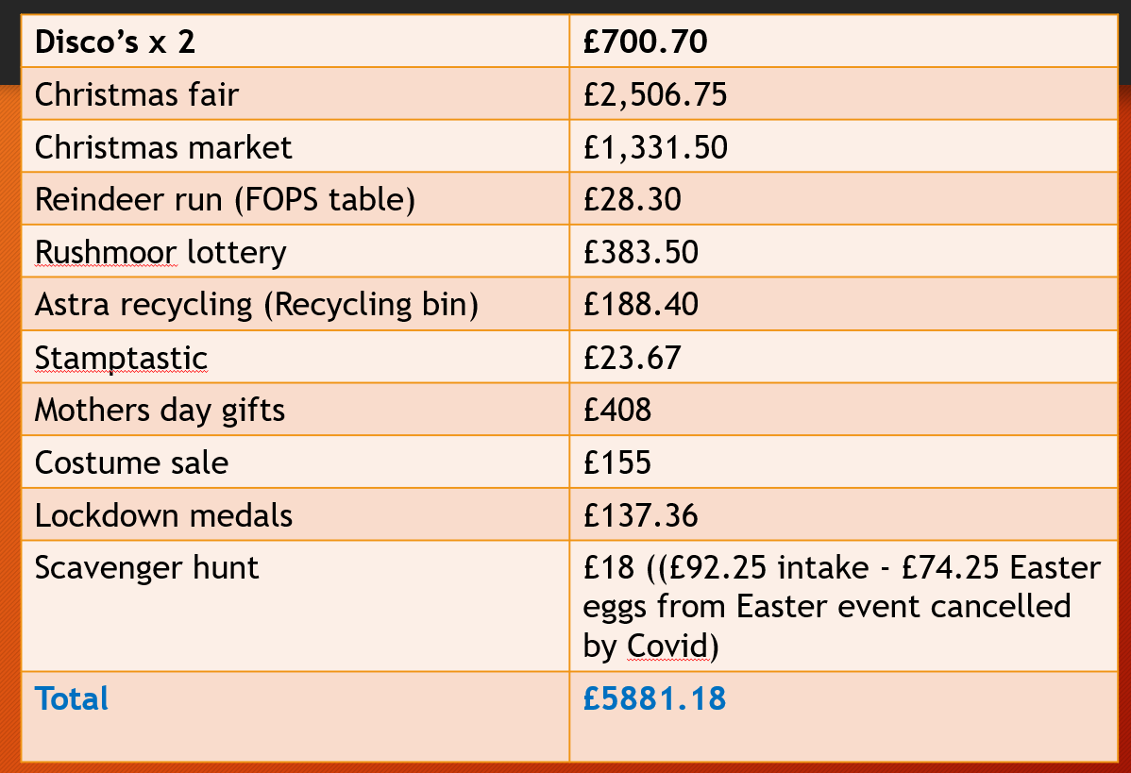  Below are the outgoings for the year  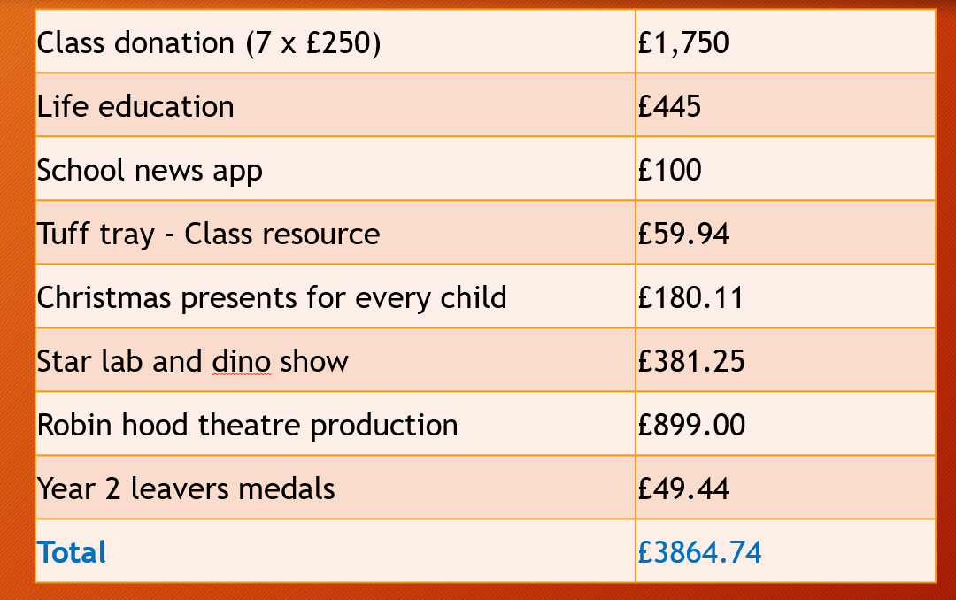  Below are what are due to come out of the FOPS account this term coming:  The school has asked for £60 for planters which the committee has agreed to pay, along with the usual £250 per class and also £710 for the life bus to visit the school which has also been agreed by the committee.  In other news we have communicated and agreed with Miss Greenway to cancel the parents app.
Actions |  | Allocated to | Deadline
Someone impartial to look over the accounts |  | Kate is going to be contacted to speak to her husband to look over the accounts. Sarah is contacting Kate | ASAP

- Ideas for events for this term- All
Dicussion | There was a discussion on the kind of events that we could be doing this year. These are the suggestions that were made:  -Virtual Balloon Race. The balloons are sold at £3 a balloon and Fops would make a profit of £2:40 a balloon. Classes could get involved as well as family’s at home. The winner will be the balloon that travels the furthest.  Everyone thought this would be a great virtual event to run but this would be better run after Christmas.  -Crispy crème doughnut sale. These would be pre-ordered and then collected from playground. This was discussed no further as we believe this would not be possible at this time  -Halloween scavenger hunt - similar to one run previously it would just be pumpkins to look out for. Not discussed any further as this is not a great money earner.  -Halloween goodie bags- these are pre-ordered and paid for in advance and then we know how many goodie bags to make up. These would then be given to children on last day of term. This is going to be discussed with the school on their thoughts on this.  -Themed mufti days- ask for a donation and the kids come in non-uniform or themes such as crazy hair, PJ’s, superhero’s. This is going to be discussed with the school see what they think.  -Virtual Santa visit- A visit into each classroom for donations. Santa could possibly read a story- This is going to be discussed with the school see what they think.  -Christmas Eve Boxes- these are pre-ordered and paid for in advance and then we know how many boxes to make up. These would then be given to children on last day of term before Christmas  -Personalised Santa Letter- these are pre-ordered and paid for in advance. Parents provide a few simple details about the child and a letter will then be created for the child. Most likely these could be hand delivered if parents are happy to provide addresses otherwise will be given to child through school  -Using a website, we can get all the children to draw a picture of themselves that can be printed onto a tea towel, bag apron. These can then be done before Christmas in the hopes that parents would order for Christmas presents for family members. This is going to be discussed with the school see what they think.  -Run a virtual raffle as this is a big money earner usually for both the Christmas and summer fair. It was discussed that online payment methods would need to be researched into to work out a cost-effective way as cannot accept cash. This may not be run this term but much rather next term  It was also discussed about running some online events e.g. quiz night, bingo, catch phrase, countdown
Actions |  | Allocated to | Deadline
- Contact the school to get approval on some of these ideas  - Look into online payment methods |  | Katy  Katy, Anna and Loreleii | ASAP

- AOB - All
Discussion | - It was discussed about how to highlight what we do raise, what it used for and what it funds for the school. Putting more information about to parents and on the website  - Anna said about getting Paula Attwood to add stuff to the school website so that everyone at the school will be able to get more information from the FOP’s page  - Anna has also said that she is in the process of getting a newsletter together to send out for all the existing parents but also welcoming all the new parents
Actions |  | Allocated to | Deadline
Newsletter to be sent out ASAP with all the other ways parents can help FOP’s  Create a Poster with an update on what has been raised this year  -Katy is going to be submitting an application on behalf of FOPs for the Rushmoor Lottery Grant for |  | Anna  Anna  Katy | ASAP  End of October  End of October

