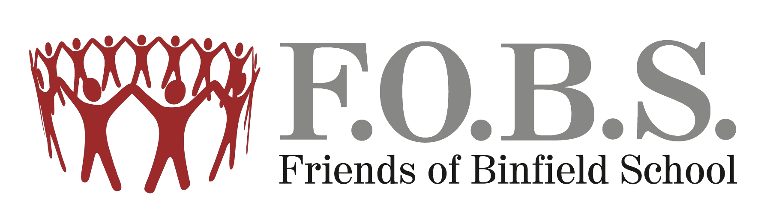
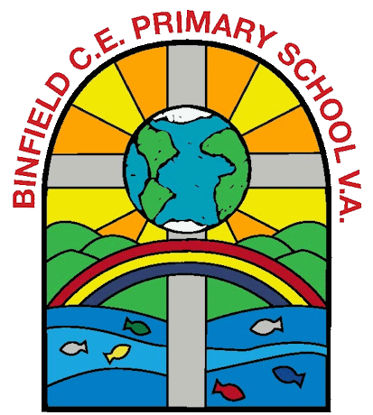
F.O.B.S Quizmas Quiz Kids
KIDS QUIZ ANSWERS

1 | 1 = Arthur Christmas
 | 2 = The Grinch
 | 3 = Rise of The Guardians
 | 4 = The Polar Express
 | 5 = Klaus
2 | Four
3 | Brussel Sprouts
4 | 1 hour 53 minutes
5 | Narnia
6 | P = Pokemon
 | R = Minecraft
 | E = Nintendo
 | S = Smarties
 | E = Lego
 | N = Nickelodeon
 | T = Fortnite
 | S = Disney
7 | Comet
 | Cupid
8 | Six
9 | 1 = Mr Bean
 | 2 = Mario
 | 3 = Chase
 | 4 = Ralph (Wreck It Ralph)
 | 5 = Harry Potter
10 | Just like the ones I used to know
11 | Kevin McCalister
12 | Orange
13 | 1 = Silent Night
 | 2 = Walking in a Winter Wonderland
 | 3 = Rocking Around the Christmas Tree
 | 4 = Rudolph The Red Nose Reindeer
14 | Widow Twankey
15 | Green

