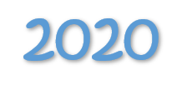
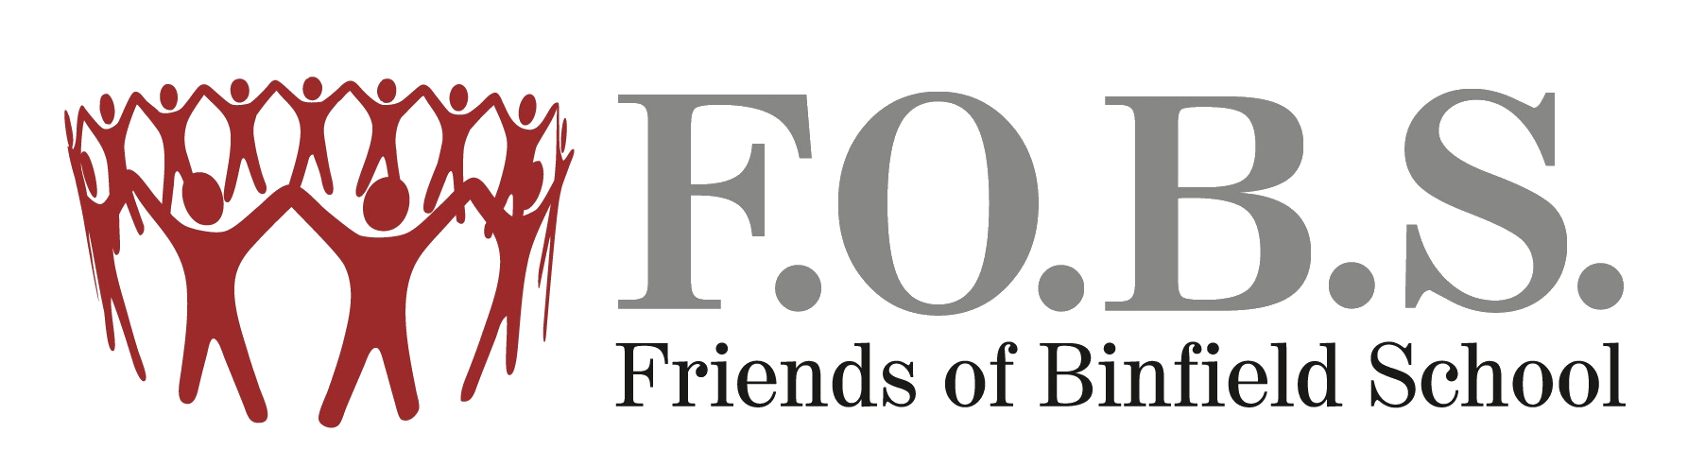
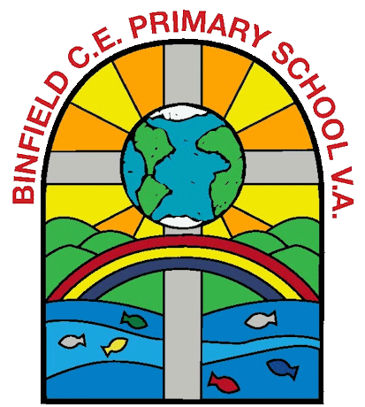
F.O.B.S Quizmas Quiz

ADULTS QUIZ ANSWERS

1 | National Lampoons Christmas Vacation
2 | Hogmanay
3 | Noddy Holder
4 | Advent
5 | Los Angeles = 4am
 | Christmas Island = 7pm
 | Israel = 2pm
 | Santa Fe = 5am (New Mexico)
 | Turkey = 3pm
 | Lapland = 2pm
6 | Last Christmas
7 | Nevada
8 | Silent Night
9 | T = Nintendo
 | U = Samsung
 | R = Ford
 | K = Knorr
 | E = Pepsi
 | Y = eBay
10 | Advocaat
11 | Miracle on 34th Street
12 | Holly Golightly
13 | Rudyard Kipling
14 | Frankincense
15 | Germany
16 | The Christmas Chronicles
17 | Bono, Paloma Faith, Guy Garvey, Ellie Goulding, Auschique Kidjo, Chris Martin, Olly Murs, Sinead O’Connor, Rita Ora, Emilie Sande, Seal, Ed Sheeran, Dan Smith, Sam Smith, Louis Tomlinson
18 | 21st December
19 | Home Alone 2 – Lost In New York
20 | Monopoly
21 | Australia
22 | White Christmas
23 | The Ivy
24 | Lego
25 | 1 = Robin Thicke
 | 2 = Robin Gibbs
 | 3 = Robyn
 | 4 = Robin Williams
 | 5 = Robin Van Persie
26 | A dog is for life, not just for Christmas
27 | Little Women
28 | 1 = Once in Royal David’s City
 | 2 = O Come All Ye Faithful
 | 3 = Away in A Manger
29 | Eleven
30 | 1 = Stay Another Day
 | 2 = Moon River
 | 3 = Mad World
 | 4 = Bohemian Rhapsody
 | 5 = Can We Fix It?
 | 6 = Mistletoe and Wine

