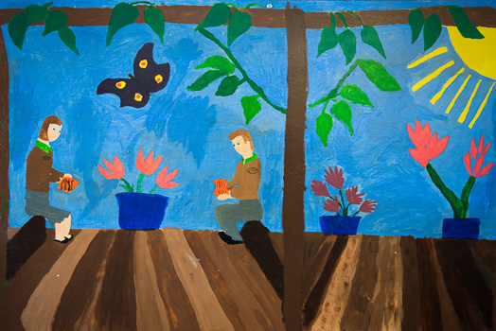 |  | Crawley Ridge Junior School Partnership  - Newsletter

Note from the Chair
Can you believe another term is coming to an end? Where is the time going? This term is always the quieter term of the 3, which only involved 3 PTA run events. All of these were well attended and enjoyed by both the children and the parents. We started off with Paddington the Movie, followed by a great disco and finished with a pack junior school hall for the annual Quiz & Chips night. From these 3 events we have raised a total of £1,101.82.

I have yet to have anyone come forward showing any interest in being Chair next year. I will be standing down and if there is no chair there will be no events for the children and no extra funding for the school, which I am sure you have all read/heard about in the news, is very much needed for all schools in this current climate. If anyone would like to have a chat with me to see what it involves please do email me, call me or grab me at the school gates.

There is good news to let you all know that the new furniture for the upstairs area of the school has been ordered. This includes the tables, chairs and lockers.

There are lots of fun events coming up in the summer term and will need lots of volunteers to come forward to help us out.

Last of all, I wish everyone a good holiday and a Happy Easter. Xenia

Special thanks to ……
Abi Summer, Ema Voinescu and Clare Taylor for movie night.

Rebecca Davis, Jenny Mcleod and Clare Taylor for the disco.

Hilary, Steve & Max Duckworth, Sharon Davies, Rebecca Davies and Abi Summers for the Quiz Night.
£6,000
£5,000
£4,000
£3,000
£2,000
£7,500

Profits this Term
Disco - £293.00
Movie night – £337.62
Quiz & Chips - £471.20

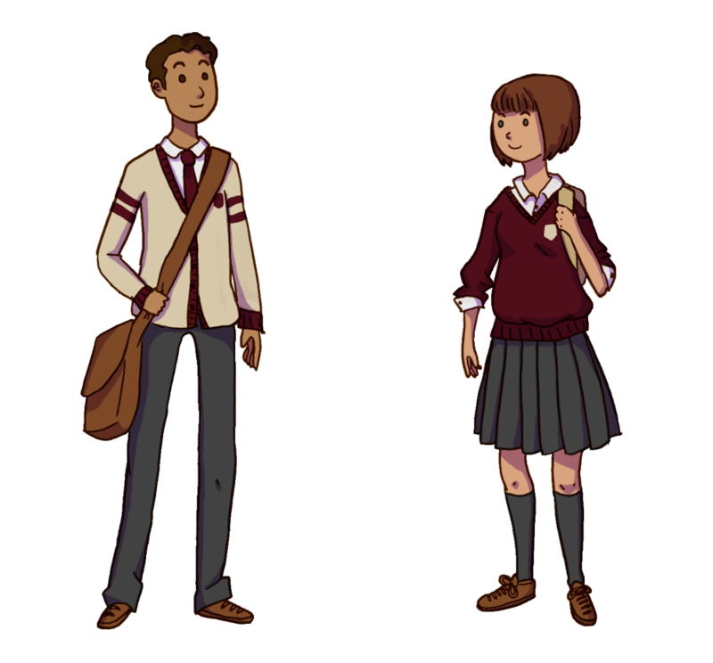
Nearly New Uniform - £11.00

Thank you to all your donations over the year, we have raised a great amount for the PTA.

Dates for your Diaries
Ascot Racing – Sun 2 April
Phil the bag – 20 April
Get Growing Day – Sat 22 April
PTA meeting – Fri 5 May
Movie night – 9 Jun
Fun run – Sun 14 May
Mufti Day – Fri 30 June
Summer Fair –
Sat 1 July – 1 – 4pm
Leaver’s Disco – Fri 14 July

Remember…
Keep on using the Giving Machine when you shop on the internet.

