How to Delete an Order
https://www.pta-events.co.uk/whitehillpta/#.W7iv32fQaAV
Go to Admin > Reports > Orders
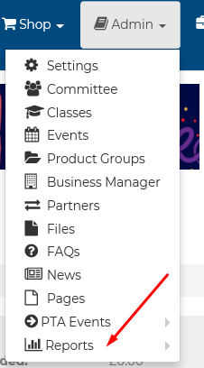
Search for the Order ID then go to Manage > Delete Order
