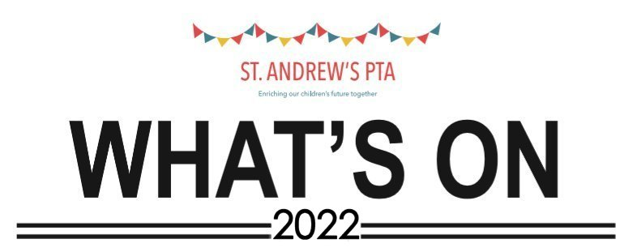
This terms What’s On Guide – listing all of our events, up to the End of Term
Feb 11th - Cake Break
Feb 24th - Non-Uniform Donation
Day
March 1st - Pancake Flip Challenge
March 23rd - Wonderful Women Shop
March 29th Spring Discos (EYFS/KS1 & KS2)
April 1st - Easter Bonnets &
- Krispy Kreme Donuts
April - Easter Raffle
For information on all our events; remember to check our Facebook page
Regularly, for details of times, prices and when tickets go on sale!
Thank You for your ongoing and continued support.
Any ticketed events will be on sale on our webpage:
www.pta-events.co.uk/standrewsptasoham
For further information please see our Facebook page: https://www.facebook.com/groups/329263937481709
Alternatively, just scan the QR codes! (Download a QR reader onto your Smartphone, open it up & scan the 2 codes to the right).
PLEASE NOTE: ALL EVENTS ARE SUBJECT TO LATEST COVID-19 RESTRICTIONS AND GUIDELINES.

