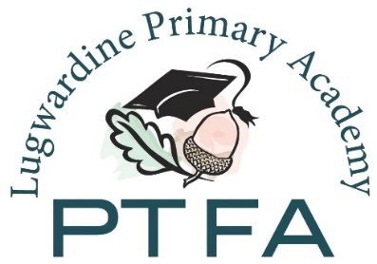

Lugwardine Primary Academy
Parent Teacher and Friends Association
Registered Charity No 1106726
General Meeting
Wednesday 29 March 2017
7pm

AGENDA
- Apologies
- Minutes of last meeting (22.02.17)
- Feedback from disco (16.03.17)
- Bingo planning (06.04.17) – timings, helpers
- Quiz planning (19.05.17) – timings, helpers, meal
- Yr 6 leavers book – confirm date
- Xmas fundraiser – IQ Cards
- Account balance, review of spending
- School wish list – update on garden and library
- AOB

Pauline
Chair, LPA PTFA

