KS2 PLAYGROUND PROJECT

Order your copy of ‘School Feels Different’ to help raise funds for the KS2 Playground Equipment!
(20% profit will be donated to this brilliant project!)
CLICK ON THE IMAGE TO ORDER YOUR COPY
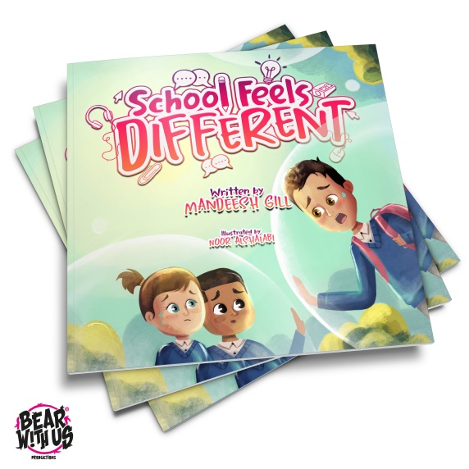
OR
EMAIL YOUR ORDER AT mandykg@hotmail.co.uk

