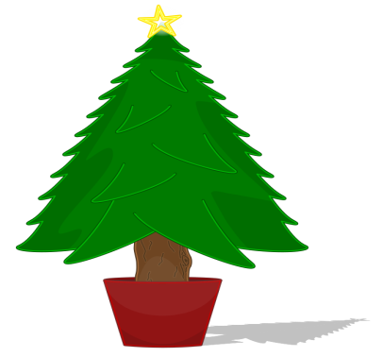
Friends of St Gregory’s Real Christmas Trees.
Order a top quality tree, save money and raise money!
All proceeds to Friends of St Gregory’s
We are overjoyed to be able to offer you the best trees in the country for a fraction of what they would retail at (think major upmarket retailer).
The trees are top quality Nordmann Fir Christmas trees, the most luxurious Christmas trees you will find. With a magical Christmassy scent, the Nordmann Fir Christmas tree has become the most popular real Christmas tree in the UK over the past few years because of its strong bushy branches, beautiful soft foliage and symmetrical shape. Nordmann Fir Christmas trees have excellent needle retention and are the ideal family Christmas tree. This has been verified by our previous years’ customers.
The order form attached shows what sizes are available to order and what you would expect to pay if buying through a normal retailer (please remember these are the highest quality you can buy) and what you will pay when ordering through us.
This offer is open to anyone so please tell your family and friends. The more trees we sell the more we can raise for our school.
Where possible please place orders can be placed online via
www.pta-events.co.uk/friendsofstgregorys with secure card payments.
Paper orders may be returned to the school office.

St Gregory’s Christmas Tree Order Form
Please return this order form along with payment to the school office.
Name ………………………………………………..
Email address ………………………………………………………………………..
Contact No. …………………………………………………………….
Size | RRP | Cost to you | Quantity
Nordmann 5-6’ (150-175cm) | £35-£45 | £31
Nordmann 6-6.5’ (175-200cm) | £37-£50 | £37
Nordmann 7’ | £50+ | £46
Deluxe water holding base | £17-25 | £15
Delivery | N/A | £5
Total | N/A | N/A
NB: All Trees will need a base.
Please make cheques payable to Friends of St Gregorys
- We have been advised that due to trees being a natural product there are variations of up to 6” in size. If you want a 6’ tree you are advised to buy a 6-6.5’
- Please note if you already have a base, the supplier will not be able to shape the tree base as they won’t know the right size of your base.
- If you are ordering a base, the tree will be made to fit
Final Order Date will be Friday 23th November
Please complete the following:
I would like to choose and collect my tree on Saturday 1st December □
I would like my tree to be delivered to the address provided on Saturday 8th December □

Delivery details
Address ……………………………………………………………………………………………………………………………………………………………………………………………………………………………………………………………………………………
Contact Tel No. ………………………………………………
Collection & Delivery will be between the hours of 10am-12pm on the specified date from Charnock Richard

