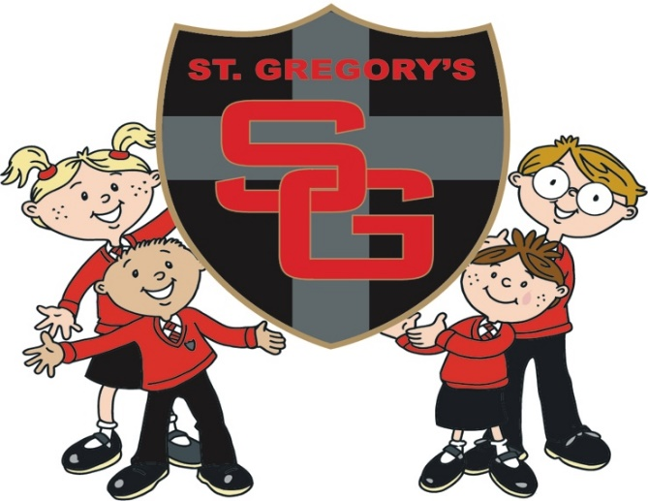
Friend’s of St Gregory’s Bog Eyed Jog 2019
Sponsorship and Gift Aid declaration form
Please sponsor me (name of participant) __________________________________________________________________________________To (name of event) __________________________________________________________________
In aid of (name of charity) ___________________________________________________
If I have ticked the box headed ‘Gift Aid? √’, I confirm that I am a UK Income or Capital Gains taxpayer. I have read this statement and want the charity named above to reclaim tax on the donation detailed below, given on the date shown. I understand that if I pay less Income Tax / or Capital Gains tax in the current tax year than the amount of Gift Aid claimed on all of my donations it is my responsibility to pay any difference. I understand the charity will reclaim 25p of tax on every £1 that I have given.
Remember: You must provide your full name, home address, postcode & ‘√’ Gift Aid for the charity to claim tax back on your donation.
Sponsor’s Full Name  (First name & surname) | Sponsor’s Home address  (only needed if are Gift Aiding your donation. Don’t give your work address if you are Gift Aiding your donation.) | Postcode | Donation Amount £ | Date paid | Gift Aid? Please √
Sponsor’s Full Name  (First name & surname) | Sponsor’s Home address  ( only needed if are Gift Aiding your donation. Don’t give your work address if you are Gift Aiding your donation.) | Postcode | Donation Amount £ | Date paid | Gift Aid? Please √
Please return all sponsorship money by Friday 24th May 2019

To be completed on the day by staff
Name ……………………..…………………………. has successfully completed ………. Laps.
Signed ……………………………………………….

DON’T FORGET TO BRING YOUR FORM ON THE DAY!

St Gregory’s Bog Eyed Jog 2019
Information for the Day
Friday 17th May 2019 9.15am (following normal registration)

- Arrive at school at the normal time in your pyjamas and trainers (or wellies if it’s wet)! Complete the minimum amount of laps for the year group (as stated below) within 30 minutes.
- Please make sure every child brings the sponsor form on the day and hands in to their teacher at registration. Without the form they may not be able to take part and have their post run snack.
- Collect sponsors from family & friends (you can collect before and after the event). Minimum of one sponsor per child is required.
- There will be prizes for those who collect the most sponsorship.
- After the Bog Eyed Jog all school children will be provided with a tasty snack before lessons start for the day. Children can spend the day in their pyjamas.
- Please note this will still go ahead if it is raining, please ensure suitable footwear and coats are provided. You may also send spare clothes/PJ’s to change into if it is wet.
- Parents and family are more than welcome to join you or cheer you on! All non St Gregory’s pupils must be supervised by an adult.
- Please ensure you bring your sponsor form on the day so we can authorise it as completed.
- Every penny raised will go towards FOSGs
- Friends of St Gregory’s will provide a snack for all school children taking part.
- Please let us know a minimum of one week in advance if your child has specific dietary requirements or if you have any additional questions.
fosg@st-gregorys-pri.lancs.sch.uk
Minimum Laps Required
Reception – 6 laps KS1 – 8 Laps KS2 16 Laps

