Crofton Infant School Uniform Size Guide
Please find below some guidance from our suppliers as to size.
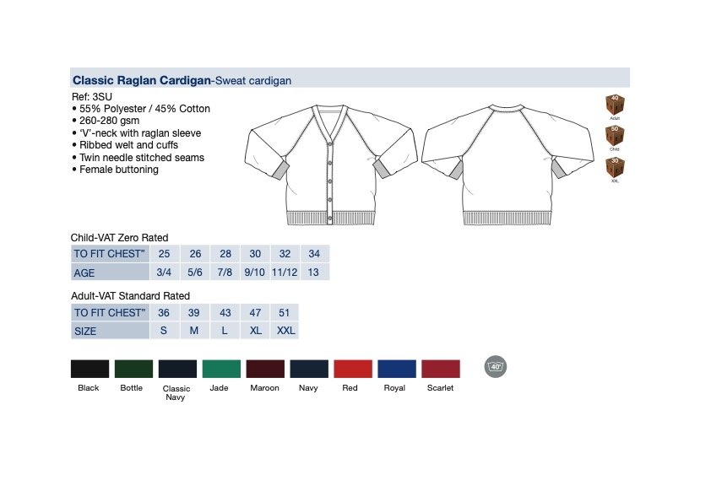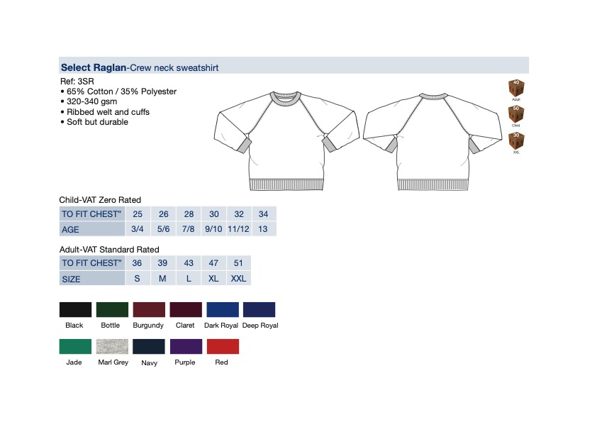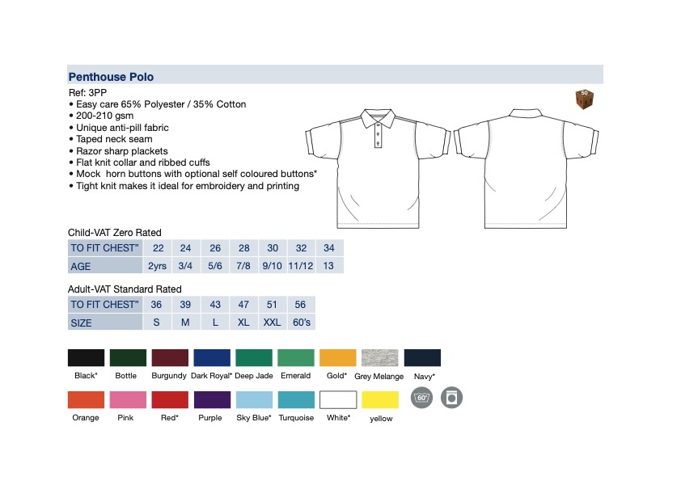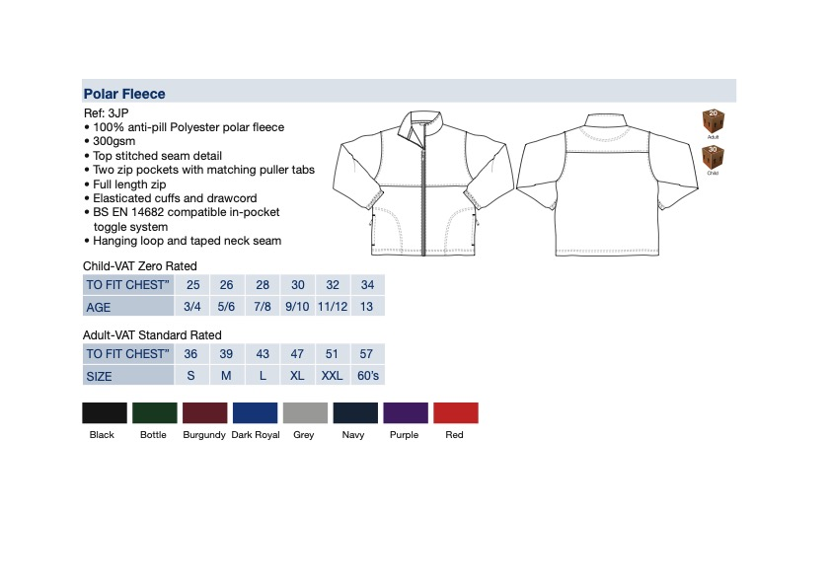

Purple Joggers
Age/Size | 3/4 | 5/6 | 7/8 | 9/10
Half waist in cm - Fully relaxed | 23 | 24 | 25 | 26
Half waist in cm - Fully extended | 38 | 41 | 44 | 46
Inside Leg in cm | 39 | 43 | 53 | 61

Purple PE shorts

Age/Size | 3/4 | 5/6 | 7/8
Waist | 18/20 | 22/24 | 26/28

Waterproof Jacket

Age | Child Height | Chest
3 - 4 Years | 98 -104 cm | 55 - 57 cm
5 - 6 Years | 110 - 116 cm | 59 - 61 cm

Waterproof trousers

Age | Child Height | Waist
3-4 Years | 98 - 104 cm | 53 - 54 cm
5-6 Years | 110 - 116 cm | 55 - 57 cm

